

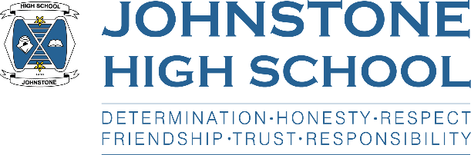

Renfrewshire Coucil

JOHNSTONE HIGH SCHOOL

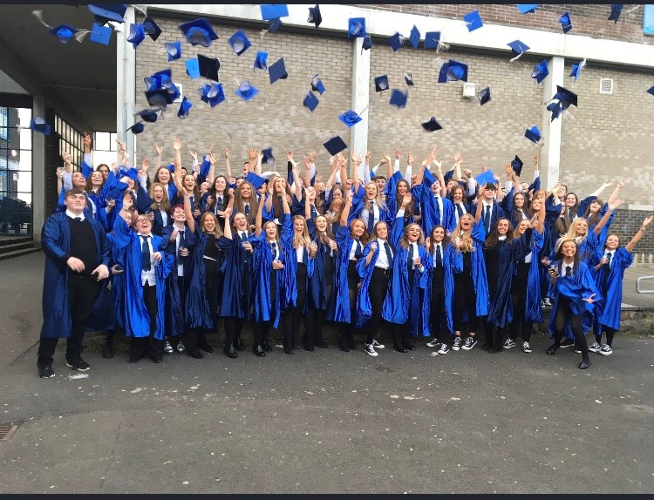

STANDARDS AND QUALITY REPORT

June 2018

This report will inform you of the school’s progress and achievements in the last session and let you know about our plans for 2018-2019. I hope that you find it helpful and informative.

Lynne Hollywood

Head Teacher

OUR VISION, VALUES AND AIMS

Our Vision:

We are a school community where everyone feels safe, valued and supported to achieve to their maximum potential. We deliver high quality learning experiences within a responsive and engaging curriculum that fully prepares our young people for the next stage in their lives. We are an ambitious school that has high expectations of learners, parents, partners and staff.

Our Values:

Determination; Friendship; Honesty; Respect; Responsibility; Trust

Our Aims:

1. To be a place that everyone is proud to belong to
2. To be a safe, nurturing and happy environment
3. To value everyone and provide opportunities for all
4. To provide excellent teaching and learning in every classroom
5. To ensure positive outcomes for all learners by developing the skills they need to compete in the modern world
6. To work in partnership with parents in the education of their children
7. To be a school firmly embedded in the heart of its community

OUR SCHOOL

Johnstone High School is a six-year non-denominational school in the Johnstone area of Renfrewshire. The school’s main catchment area covers Johnstone and the surrounding areas of Howwood, Kilbarchan and Lochwinnoch. The school has 7 associated primary schools. The catchment areas are a mix of local authority, traditional and new housing in both urban and rural environments. Many pupils are bused to school from the furthest villages. There is an active, oversubscribed parent council that has been in place for three sessions.

The school roll is projected to be 976 as of August 2018. The percentage of pupils claiming free school meals is 16%. The SIMD profile is 44% from SIMD 1-3.

The school was visited by Education Scotland in November 2016 and given ratings of satisfactory in: raising attainment, learning teaching and assessment; and leadership of change. The school received a grading of weak in equality, inclusion and wellbeing. As a result we received a continuing engagement visit in February 2018 when the inspectors noted the strong vision for improvement and the progress that the school made since their last visit. As a result Education Scotland has no further plans to visit our school.

SUCCESSES AND ACHIEVEMENTS

* Leaver destinations – 94% of our leavers go on to a positive, post-school destination. This is in line with national statistics and is an 8% increase in 2 years.
* Attainment – comparing 2017 results with 2016 results:
  + S6: improvements at 1+, 3+ and 5+ Highers
  + S5: improvements at 3+ and 5+ Highers; improvements in 5+ National 5s
  + S4: improvements in 1+, 3+ and 7+ National 5s
* **Pupil achievement:**

***Sporting***

In Athletics, successes came with a range of medals at the Renfrewshire Championships with 4 members of the team selected to represent Renfrewshire at the Inter-Authority Championships.

At the Renfrewshire Cross Country and Road Race events, 3 gold, 1 silver and a bronze medal were won.

We also had pupil successes in Triathalon, Badminton, Football, Netball, Dance, Boxing, Swimming, Ice Hockey and Volleyball. Our Senior Basketball team make it to the Semi Finals of the Scottish Plate competition.

Our sports award winner is the current British Freestyle Snowboarding champion.

***Musical***

This session saw one of our pupils successfully gain a place at the prestigious St Mary’s School of Music in Edinburgh. A number of our pupils won entry to the National Youth Pipe Band, with successes at the Novice Junior Category and the British Pipe Band Championships.

Our School Choir, orchestra pipe band and folk group are travelling to Belgium to perform.

* Our new website went live in January 2018 and is getting positive feedback from parents and partners in terms of information and ease of use
* Our strong relationship with our Parent Council who have been very supportive and have both a political and a fundraising dimension. To date they have raised £20,000 from grant applications and school events (e.g. winter fayre) for a school ground refurbishment which should take place over the summer holiday period.
* This year we have partnered with Columba 1400 to develop pupil leadership using a values based approach. 15 S3 pupils and 5 staff went to the Columba 1400 centre in Staffin, Skye in March 2018 to develop their leadership and engage in personal reflection.
* This year we got involved in the Youth Philanthropy Initiative. All of S3 took part and worked in teams to research local problems and issues, and charities that are supporting these. Each team picked a charity to support and the short listed teams took part in a celebration event and presentation with the winning charity (Renfrewshire Women’s Aid) being gifted £3000 from YPI who are funded through the Wood Family Foundation.
* We continue to offer a range of extra-curricular activities, supported study and Easter school and our thanks to staff for their continuing goodwill
* Similarly, we continue to offer a wealth of in-house guests, external trips and residential experiences to our pupils. These have included:
  + Gathering the Voices (holocaust exhibition and assemblies);
  + A range of employers and providers;
  + MPs, MSPs, Councillors, Holyrood;
  + Hunterston, Thales, Mission Discovery, Robot Wars and the Science Centre;
  + West College, University West of Scotland and a range of HE/FE careers events;
  + Theatre, cinema and French restaurants;
  + Belgium music tour, Ardentinny, Skye, London, World Challenge;
  + A full programme for end of term activities including the JHS Carnival day
  + Sky Studios;
  + Dumfries House Sewing Challenge, Tennents, local hotels/hospitality venues etc.

**HOW SUCCESSFUL HAVE WE BEEN IN IMPROVING OUR SCHOOL?**

**School Leadership**

* We have focused on leadership for staff at all levels. We have delivered our own aspiring leader programme, have invested in a bespoke programme for our middle and senior leaders, and have supported our staff to take part in the authority ‘Aspiring Leader Programme’. As a result we have internally promoted a number of staff to PT and DHT levels and saw a DHT move to headship. Leadership is driving overall school improvement.
* Staff are taking on leadership by taking part in teacher learning communities (TLCs), learning walks and health and wellbeing collegiate groups (see below). Staff continue to take on a range of volunteer roles.
* We put in place our new house structure this session. S1-4 are in house teams; S5/6 are in a senior team. All pupils are closely monitored and provided with support and challenge by their DHT / PT team. We are seeing improvements in attendance, behaviour and attainment as a result.

**Teacher Professionalism**

* TLCs and learning walks have seen staff engage in professional reading and reflection and get together to discuss, share and observe good practice. 20 staff delivered workshops during our learning and teaching showcase event in May.
* Health and wellbeing working groups have taken place but time and capacity (and the focus on TLCs) means that these have not had the same impact. These will continue on a voluntary basis moving forward.
* We have carried out an audit of best practice in learning and teaching and from this we were able to put together the JHS Lesson after consultation with all stakeholders. This is helping create a consistent approach.
* We have made in-roads into a universal approach to universal support but more requires to be done here.

**Parental Engagement**

* We have continued to prioritise communication with parents and this year have embedded ‘show my homework’, the school app, Twitter, put in place a more user-friendly website, supported staff on writing reports that focus on feedback and next steps, and we have developed our termly newsletters.
* The nurture base has supported parental engagement where children need more intensive support
* The inclusion support officer (appointed in time for session 17/18) has engaged with a wide range of families
* Our Parents in Partnership programme has focused on P7/S1 parents with a number of events, most notably two twilight taster sessions for parents to sample the canteen menu. 220 attended the session in June.

**Assessment of Children’s Progress**

* We have reviewed our assessment procedures in the BGE to include embedded use of benchmarks, standardised assessments and moderation.

**School Improvement**

* Nurturing approaches training has been delivered for staff and continues to be a priority
* After consultation, we launched our new Respect for All (Anti-bullying) policy. This needs to be embedded.
* The pastoral team review the PSE Programme, asking pupils for their views. Changes were made and mental health is an ongoing concern. The LGBT pupil group helped write curricular inserts this session.
* The learning and teaching policy is in draft form. This needs to be launched in 2018/19, alongside an assessment policy.
* More needs to be done in the following areas: embedding the wellbeing indicators in the curriculum; further developing wider achievement in both the BGE and senior phase; pupil leadership opportunities from S1-6.

**Performance Information**

* Our new house structure and weekly tracking are supporting early intervention and therefore improved outcomes for pupils.

**School Name: Johnstone High School**

**School Address: Beith Rd, Johnstone, PA5 0JN**

**Phone:01505 322173**

**Website: www.johnstonehigh.co.uk**

**Follow us on twitter!**

**School App: myschoolapp (Search all platforms)**

HAVE YOUR SAY!

Please take the opportunity to share your thoughts with us as we use feedback to help us make improvements to the school. You can do this by speaking to staff, participating in the Parent Council, responding to questionnaires/surveys and by completing evaluations at school events.

KEY STRENGTHS OF THE SCHOOL

* **Education Scotland in their March 2017** letter highlighted the following strengths:
  + The strong leadership of the head teacher who has a clear vision for what the school can achieve. The head teacher has a relentless drive to ensure the highest possible standards for all young people at Johnstone High School. Together with other leaders in the school, she has made a strong start to bringing about improvements in the school.
  + Most young people are ready to learn, cooperative, and confident in giving their views. They are keen to take an increasingly active role in their learning, and in the life and work of the school.
  + The curriculum is meeting the needs of most young people from S4-S6 through an increasing range of courses and opportunities for achievement.
  + The school’s progress in working with partners to enrich the learning experience of young people.
* **Education Scotland continuing engagement June 2018** letter stated that they are satisfied with the progress being made and have no plans to visit the school again. Highlights included:
  + Culture of school improvement focused on our vision and values
  + An inclusive and supportive learning and working environment
  + Streamlined improvement planning
  + Increasing opportunities for young people
  + Positive relationship with the Parent Council
  + Teacher professional learning groups are improving pupil learning experiences
  + The JHS lesson sets out clear expectations around learning and teaching
  + Pupil behaviour and motivation
  + A strong foundation for improving pupil health and wellbeing
  + Our use of data and tracking to plan for improvements in pupil attainment
  + Our use of attainment challenge / PEF funds to target support
  + Stakeholder consultation to review curricular provision S1-3
  + Improved courses and programmes to cater more effectively for pupils in S1-3

OUR NEXT STEPS – PRIORITIES FOR 2018-19

We believe that we have made good progress during session 2017-18 and we will use the improvement priorities listed below to build on this progress moving forward.

* Health and wellbeing: Embed nurturing approaches and develop our nurture base; deliver staff training on adverse childhood experiences and resilience; embed the new house structure and promote house identity; develop a strategic approach universal personal support through positive relationships; we will embed the wellbeing indicators in the curriculum; we will continue to work on wider achievement and leadership opportunities for pupils; we will make sure PSE meets the needs of our pupils; we will deliver mental health first aid training for staff and invest in an in-school counselling service; we will embed our new Respect for All policy and ensure pupils take a lead role in this.
* Learning and Teaching: We will continue to develop Teacher Learning Communities and the learning walk programme to improve our practice; we will establish pupil and parent versions of the JHS lesson; we will embed new procedures to ensure robust assessment in the BGE; we will write new policies for learning and teaching and also assessment; we will embed pupil voice into decision-making in the school.

Full details of the school’s improvement priorities and actions are detailed on the school improvement plan which can be accessed on our website or by contacting the school office.