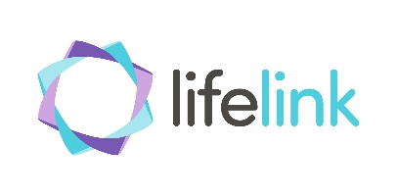
Lifelink School Counselling is available to young people aged 12 to 18 who attend schools in Renfrewshire, West Dunbartonshire or Glasgow.

Due to school closures and the current challenging times where, social distancing is necessary Lifelinks youth counselling service has moved from school venues to a telephone/video counselling service.

Telephone/Video counselling is a great way of connecting to a therapist during these challenging times and can offer the same level of support at face to face counselling.

Young people who feel that they would benefit from accessing counsellor or for those who currently see a counsellor in school or were waiting to see a counsellor can gain access to the new Telephone/ Video sessions available.

To access counselling support please call us on 0141 552 4434 or go online to Lifelink.org.uk https://www.lifelink.org.uk/make-a-referral/ and submit a referral through with your personal details including phone number and email.

Ongoing updates and communication will be provided via our website and social media channels and we recommend that schools subscribe to these to be in touch with the latest news by visiting lifelink.org.uk and signing up to the various feeds

