[](https://www.google.co.uk/url?sa=i&url=https%3A%2F%2Fwww.gla.ac.uk%2Fmyglasgow%2Fstaff%2Fbrandguidelines%2Fessentials%2Fmarque%2F&psig=AOvVaw1TFhLG7Y7ue3ortmZrR1mx&ust=1576250458484000&source=images&cd=vfe&ved=0CAIQjRxqFwoTCLC0w-m0sOYCFQAAAAAdAAAAABAD) 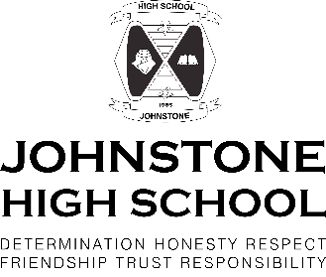

*Are you planning to go to university at the end of S5 or end of S6?*

*Do you wish to study any of the following courses?*

*Law Dentistry*

*Medicine Primary Teaching*

*Vet Medicine Accounting*

*Engineering*

Johnstone High School and University of Glasgow are now seeking S4 pupils to include in their very successful REACH and ACCESS programmes.

You will get help with UCAS applications, boosted grades in external tests, help with personal statements and work shadowing. You will get the chance to attend university days too.

We have run this programme for over 7 years now and it has proven to be very successful.

*What should you do now?*

1. *Email Mr Munro with the following information*

*His email address is* [*graham.munro@renfrewshire.school*](mailto:graham.munro@renfrewshire.school)

*Name*

*Class*

*What one of the above courses you plan to study (It’s okay if you are not sure and need to say two)*

1. *He will email you back with a link to University of Glasgow that will take you through the steps you need to follow.*