Johnstone High School 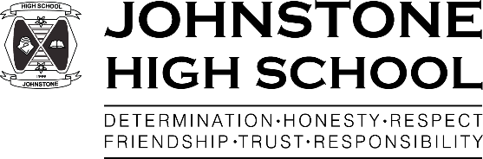

Beith Road

Johnstone

PA5 0JN

Tel: 0300 300 1331

[www.johnstonehigh@renfrewshire.gov.uk](http://www.johnstonehigh@renfrewshire.gov.uk)

johnstonehighenquiries@renfrewshire.gov.uk

28th July 2020

Dear Parent / Carer,

**SUMMER HOLIDAY UPDATE**

I am writing with a brief update for parents as we near the end of the school holidays.

As you may recall, the last week of June saw us get in touch with you regarding the ‘blended model’ of learning and then again when the Depute First Minister John Swinney stated that the aim was to return pupils to school on a full time basis.

The Scottish government will update us on the position regarding the reopening of schools on the 30th of July. We will then finalise our plans in consultation with Renfrewshire Council.

The following week each family will be sent their child’s timetable and an information pack through the post (please call the school office if your address has changed). This will set out our plans for the safe return of your child to school.

In the meantime, I know many of you will be in the process of purchasing school uniform. As was mentioned in the letter to parents in June, our uniform is as follows:

|  |  |
| --- | --- |
| **Standard school uniform** | **Standard PE kit** |
| Black skirt / trousers  White shirt  School tie*  Black shoes  Warm/waterproof jacket  Blazers remain a popular option* | Generic:  Dark jogging bottoms / shorts  Plain white t-shirt / polo shirt  Appropriate supportive training shoes  Or  Blue branded JHS top and shorts* |

*Branded items can be found at local uniform suppliers.

Please note thathigh street / supermarket uniform is perfectly acceptable.

Pupils in S4-6 will receive their SQA results on Tuesday 4th August. We wish them all the very best of luck and we have been tweeting links to useful sites such as Skills Development Scotland. From Tuesday, staff will be available to answer any SQA related queries.

Finally, if any pupil requires to discuss their current course choices as a result of their SQA awards, please note that from Tuesday 4th August appointments can be made via the school office to speak to senior/pastoral staff. Nearer the time, parents of senior pupils will be sent a text message with more information about this.

Yours sincerely,



Lynne Hollywood

Head Teacher