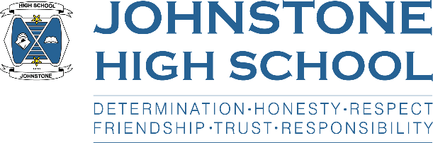
JHS SQA Results 2020

Pupils should have received their results today via text or post.
If a young person hasn’t received their results, then please phone the school office on 0300 300 1331.

Some pupils will be pleased with their grades; others may be disappointed. This may result in an appeal, or a request to review course choices. Information about both is provided below.

SQA Appeals Process 2020

Due to the situation around Covid and the cancellation of the 2020 examination diet, SQA will have a free appeals service for 2020. This service is available where the result awarded is lower than the estimated grade sent by the school to the SQA in May.

The principal teachers (PTs) in each department will be reviewing all results. For results which were downgraded by SQA from the school’s estimated grade, PTs will make sure that there is appropriate evidence available to support the appeal.

For the appeal to be made we will need pupil consent. For pupils in the new S5/6, on your return to school on 12th or 13th of August, you will need to have a discussion with the PT of the department to make sure you are fully aware of all the possible outcomes and sign the appeal request form to show you have given consent.

Principal Teachers

Art and Photography | Mr Sheppard
Admin, Business and Computing | Mr McGivern
Biology, Chemistry and Physics | Mr McKenzie
English | Mr Clark
Maths | Mrs Colford
Geography, History, Modern Studies and Politics | Mrs Robertson
French, German and Spanish | Mrs Kilgour
Graphics, Practical Woodwork and Practical Metalwork | Ms Smith (new member of staff)
PE, Practical Cookery, Practical Cake Craft and Fashion | Mr Merriman
Music and Music Technology | Mrs Davidson
Psychology | Mr Smith (Class teacher)/ Ms Cole DHT
The deadline for Appeal Requests for new S5/S6 is Thursday 20th August.
Leavers
Priority will be given to those who are needing a result to secure a conditional place at college or university. The deadline for priority requests Is Friday 14th August 2020.

All leavers who are requesting an appeal should phone the school office on 0300 300 1331 to make an appointment to come in and sign the paperwork for the appeal before this date.

The Process
The appeal and all the associated assessment evidence will be reviewed by SQA’s senior subject specialist examiners. They will either accept or reject the appeal based on the evidence provided.

- If our appeal request is accepted, your result will be upgraded. If you require the result for a conditional college or university place, SQA will contact us at school and advise the higher education institute and UCAS, as appropriate. An updated Scottish Qualifications Certificate will be sent to you after all appeals for 2020 have been completed.
- If our appeal request is rejected, SQA will confirm either the original grade on your certificate or a lower grade. This information will be sent to us at school so that we can talk to you about it.
- It is possible that a lower grade could be awarded following an appeal however, SQA expect cases of this to be very rare.
You can find more information about 2020 Qualifications on SQA’s dedicated learner and parent and carer webpages.

S5/6 Course Renegotiations

Any pupils in the new S5/6 requiring a change of subject as a result of their SQA results should contact the school office on 0300 300 1331 to arrange a telephone interview with Mr Menzies. (Due to the Covid situation, we are following guidance and minimising visitors to the school.)

These phone interviews will take place on Thursday 6th and Friday 7th August.

Please note that this service is only for pupils requiring a course change as a result of their SQA results.

