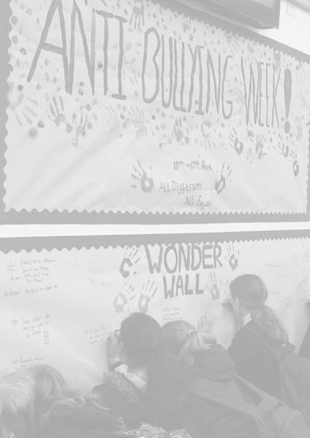
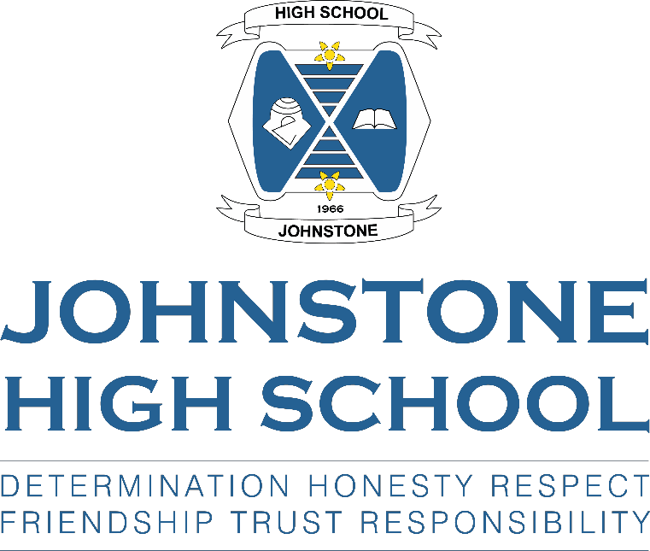

Respect for All Policy
Our approach to anti-bullying

January 2019
(Updated November 2020)

Purpose and Vision

This policy has been developed in line with Renfrewshire’s policy on anti-bullying which can be found by following this link:
http://www.renfrewshire.gov.uk/bullying
At Johnstone High School it is our aim that all members of our school community will contribute to a positive school ethos in which bullying behaviour, regardless of type, is not tolerated.

What do we mean by bullying?

Bullying is both behaviour and impact; the impact is on a person’s capacity to feel in control of themselves. This is what we term as their sense of ‘agency’. Bullying takes place in the context of relationships; it is behaviour that can make people feel hurt, threatened, frightened, left out, and lack self-confidence. This behaviour happens face to face and online.
(respectme, 2015)

This behaviour can harm people physically or emotionally and, although the actual behaviour may not be repeated, the threat may be sustained over time, typically by actions, looks, messages, confrontations, physical interventions, or the fear of these.

Prejudice-based bullying is when bullying behaviour is motivated by prejudice based on an individual’s actual or perceived identity; it can be based on characteristics unique to a member of our school community’s identity or circumstance. For example, prejudice arising from socio-economic background, their ability to learn, mental health or a pupil’s appearance.

Online bullying, or ‘cyberbullying’ as it is often referred to on social networking sites and online gaming platforms will not be treated any differently from face-to-face bullying. A person can be called names, threatened or have rumours spread about them and this can (like other behaviours) happen in person and online.

Whole School Principles/Values
Our school values underpin our approach to Respect for All:

DETERMINATION FRIENDSHIP HONESTY RESPECT RESPONSIBILITY TRUST

We are a school community where everyone feels safe, valued and supported to achieve their maximum potential. We deliver high quality learning experiences within a responsive and engaging curriculum that fully prepares our young people for the next stage in their lives. We are an ambitious school that has high expectations of learners, parents and staff. We are committed to creating an environment where bullying behaviour cannot thrive.

It is the responsibility of all members of our school community to prevent bullying. There are specific strategies which we are committed to as a school community:

  - Positive school culture and ethos.

  - Anti-bullying professional learning.

  - Recognising and realising Children’s Rights.

  - Rights Respecting School.

  - Restorative approaches.

  - Creating inclusive and supportive learning environments.

  - Solution oriented approaches.

  - Nurturing approaches.

  - Mentoring and peer support (including Mentors in Violence Prevention [MVP] and LGBT group).

  - Curriculum for Excellence.

  - Staff and parents model positive behaviour towards others.

  - High profile of anti-bullying week.

  - LGBT Youth Scotland Charter Mark journey.

  - Wellbeing transition day for P7 pupils.

  - Open access for pupils to seek support from Pupil Support staff through email, pupil contact sheets and the Pupil Support base.

As a school community we:

  - Take members of our school community seriously when they talk about bullying.

  - Know about and promote the Johnstone High School Respect for All policy.

  - Challenge inappropriate behaviour immediately.

  - Think about how to stop bullying before it happens.

  - Ensure all pupils, parents and staff are included, engaged and involved and have the opportunity to participate fully in our school community.

The Equality Act 2010

The Equality Act 2010 creates a duty on schools to have due regard to the need to: eliminate discrimination, harassment and victimisation; advance equality of opportunity; and, to foster good relations between people who share a relevant protected characteristic and those who do not. The protected characteristics are as follows:

- Age;
- Disability;
- Gender reassignment;
- Pregnancy and maternity;
- Race;
- Religion and belief;
- Sex;
- Sexual orientation;
- Marriage and Civil Partnership

More information about each protected characteristic can be found in the Renfrewshire Council Anti-Bullying Policy.

LGBT+ Community

We promote a safe environment where all members of our school community can be themselves. We respect that every member of our school community has many parts to their identity and that being LGBT+ may be one of the many layers. We actively support LGBT+ and non-LGBT+ pupils through our Umbrella group which meets regularly at lunchtime, providing a safe place and is a source of information and support.

Our Personal and Social Education programme explores all types of relationships as well as what it means to identify as LGBT+.

We work closely with pupils, parents, staff and health professionals in supporting members of our school community who are transitioning gender. We also provide access to gender neutral toilet facilities.

Johnstone High School are committed to supporting LGBT young people, families, visitors and staff. We are working towards our LGBT Youth Scotland Charter Mark at Silver level. Staff from across the school have received training to enhance their confidence in addressing homophobic, biphobic and transphobic bullying. We will continue to develop this throughout our Charter journey.

When is it not bullying behaviour?

It is important that our pupils are able to discuss how they feel and develop resilience to manage their relationships. We know that pupils will fall out and disagree with each other as they form and build relationships. This is a normal part of growing up and most young people have the ability to bounce back from this type of behaviour.

Early intervention and prevention through education and modelling behaviour are key elements to ensuring we get it right for all members of our school community.

Behaviour Expectations

We have high expectations of conduct from all members of our school community. We build our school culture and ethos on a base of respect. Alongside the development of nurturing approaches we actively seek to build positive relationships between pupils, staff and parents.

Typical behaviours we encourage and praise include:

- Kindness in actions and words towards others.

- Acceptance of diversity.

- Listening attentively.

- Encouraging positive behaviour in others.

- Standing up against negative behaviour.

- Including others.

- Prompt reporting of bullying behaviour.

Responsibilities of Pupils

As a school community we fully embrace the practices of Mentors in Violence Prevention (MVP). It is the responsibility of all members of our school community to demonstrate Respect for All at all times. In situations where pupils witness behaviour which is not appropriate towards others, pupils are empowered to challenge such behaviour by speaking out. It is important that pupils report bullying type behaviour immediately to Pastoral Support staff or any other member of teaching staff. Pupils who are displaying bullying type behaviour and those who are subjected to such behaviour are encouraged to take part in restorative work to ensure issues are resolved quickly and have no lasting impact.

Responsibilities of Staff

As a nurturing school community which promotes positive behaviour, all members of staff are expected to model positive relationships with pupils, parents and staff. If staff witness or have an incident of bullying behaviour reported to them, they will deal with the situation immediately. Staff should challenge all forms of bullying behaviour, including the inappropriate use of language such as “that’s gay” at the time of occurrence and use each situation as a learning opportunity. All incidents must be reported to Pastoral Support staff for logging and further action if appropriate.

Pastoral Support staff will take a lead role in supporting and challenging pupils to sustain positive relationships and build skills to improve resilience and abilities to form positive relationships with others.

When responding to incidents or accusations of bullying staff will ask themselves:

- What is the behaviour?

- What impact did it have?

- What do I need to do about it?

Parents feel strongly that bullying and challenging behaviour needs to be addressed. They overwhelmingly told us that children who bully and their families should be supported. In response to this, pupils who are exhibiting bullying behaviour will be given help and support to:

- Identify the feelings that cause them to act this way.

- Develop alternative ways of responding to these feelings.

- Understand the impact of their behaviour on other people.

- Repair relationships.

Pupils who demonstrate bullying behaviour will be provided with clear expectations about behaviour as well as a range of appropriate ways to respond. This may include taking steps to repair a relationship, and where appropriate, supporting them to make amends. We will challenge prejudice and offer the opportunity to learn and change behaviour. Consideration will be given to any factors that may impact upon a pupil’s wellbeing, including whether any additional support for learning is required.

When restorative and supportive strategies put in place by Pastoral Support staff have not brought about a positive change in behaviour, Depute Head Teachers will put in place a suite of supports for pupils involved.

Responsibilities of Parents/Carers

We consulted with parents and carers (Dec/Jan 2019) and in line with their wishes we will continue to work in partnership and recognise that behaviour and relationships is a joint responsibility between home and school. Being subjected to bullying behaviour can have an impact of a young person’s demeanour and general mood or wellbeing. Parents should report any changes in their child that they are concerned about. Daily family discussions about school and probing further rather than accepting “fine” as an answer to how a child’s day has gone will help our pupils speak out about the behaviour they are experiencing or displaying. In consultation with pupils they told us that sometimes parental responses to bullying can be a stressor for them. Therefore we would ask parents and carers to be mindful of this and ask that they are calm and listen to their children’s wishes before responding.

Often bullying behaviour happens online. We strongly encourage parents/carers to monitor their child’s use of technology and ask them to challenge any negative usage as well as support their child if they are receiving bullying messages. We recommend that social media accounts are private and only agreed friendship groups are able to post messages, etc. Inappropriate online usage can be reported to Police Scotland by
parents, however reporting misuse to the school’s Pastoral Support team will also allow supports to be put in place in school.

Recording bullying incidents

In line with Renfrewshire Council guidance, all incidents assessed as bullying will be recorded on Seemis, our electronic management of information system. Pastoral Support staff and DHT’s can access the “Bullying Log” in Seemis through Management → Bullying and Equalities.
Each incident recorded should include the following details:
  - Pupil information relating to those experiencing and displaying bullying behaviour.

  - Details of alleged incident.

  - Nature of incident including the characteristic of the type of behaviour.

  - Procedures to monitor and review targets with dates as required.

  - Progress of outcomes following review (within timescale set).

Parents/Carers of all pupils should be informed and details recorded on Seemis Pastoral Notes and the Pupil Chronology. It is essential that Pastoral Support staff and DHT’s refer to the Bullying Log, Pastoral Notes and Pupil Chronology when recording new incidents to compare information and highlight patterns of behaviour.

Policy Creation and Review

Written January 2018
Updated January 2019
This policy is designed to serve all members of the Johnstone High School Community and as a result pupil, parents and staff have been involved in the creation of this policy. We are committed to reviewing and amending the policy, as necessary, on a three yearly cycle.

Acknowledgments

This policy has in the most part been derived from guidance and information shared in Respect for All: The National Approach to Anti-Bullying for Scotland’s Children and Young People 2017.

