

**Head Teacher Update**

**29th January 2021**

Dear Parent / Carer,

As we approach the end of January having completed three weeks of remote learning, two things have become increasingly clear to me. Firstly, pupils and staff are working incredibly hard on getting remote learning right; and secondly, that it has never been so important for everyone in the Johnstone High School community to look after each other.

We know that some families and pupils are having a particularly tough time, and this can be because due to any number of reasons. Health worries, stress over remote learning, financial concerns and even the tension resulting from families spending so much time together – all of these can have an impact on the strongest and most resilient people. Please get in touch if you need to speak to someone. 0300 300 1331. If we can’t help, we will signpost you to someone who can.

As I mentioned previously, it is my intention over this second lockdown to keep you up to date each week on school life. This week I am pleased to include some updates from other members of staff.

**Holiday reminder**

Our February holiday is Monday 8th and Tuesday 9th February, with an in-service day for staff on Wednesday 10th. Pupils resume learning on Thursday 11th, whether that is remotely or in school via a keyworker place.

Therefore there will be no remote learning on:

Monday 8th

Tuesday 9th

Wednesday 10th

**Monitoring engagement**

We are continuing to monitor the engagement of our pupils in the remote learning offer we are providing. This is for two reasons; from a statutory safeguarding point of view we need to check-in regularly to ensure all pupils are well, and also, we need to make sure they are not falling behind in their learning.

Some parents may have received ‘non-engagement’ texts home this week. We realise that some of you may have received more than one text if your child has not engaged across a range of subjects. Please bear with us as we refine our system so that you don’t get multiple contacts.

**SQA update**

It was announced this week that the SQA have moved the deadline for provisional teacher professional judgment grades to 18th June 2021.

Here is an update for parents/carers from the SQA website:

***A message for parents and carers 27 January 2021***

*With remote learning continuing until at least mid-February, the National Qualifications 2021 Group* appreciates that you may be anxious to know how this will impact on your child and their school or college.*

*We have written to schools and colleges to remind them that maximising learning and teaching time remains the current priority. Overall assessment of your child’s educational achievements (also described as attainment) should therefore take place once they are back in school or college.*

*Evidence of your child’s attainment remains a key part of awarding their grades in 2021. During January and February 2021, SQA is publishing subject-specific guidance and assessment resources for Higher and Advanced Higher courses. This will support teachers and lecturers with assessment planning for later in the 2020-21 session.*

*Understanding Standards*

*Ensuring that your child’s assessment is marked to the national standard is critical for reassuring everyone that qualification results in 2021 are credible. Teachers and lecturers are being supported by Understanding Standards resources produced by SQA. These resources form an important part of quality assurance and support teachers and lecturers by helping them strengthen their understanding of the national standard required for assessment.*

As mentioned last week, the focus at the moment is on learning and teaching and we will pick up on assessment when the seniors return to the building. Our in-service day in February will be spent on planning our assessment approaches in advance of the seniors returning to school. All Renfrewshire secondary schools will be working together in the afternoon to quality assure these approaches and ensure consistently high standards.

**S3 reports – insert from Ms Cole, DHT**

S3 pupils were due to have a written report issued to them at the end of February. In light of the current restrictions in place and the absence of in class teaching/assessment we have made the decision to postpone these reports to later in the academic year. Please continue to monitor your child’s engagement on Satchel 1/MS teams and liaise with your child’s pastoral teacher if you have any concerns.

**Surveys**

Last week we put a survey out to pupils on remote learning. The results were very encouraging and where pupils have expressed concern, we have investigated further e.g. we found out that many S1 were commenting on the difference between the primary approach (from when they were in P7), compared with the expectations now they are in high school.

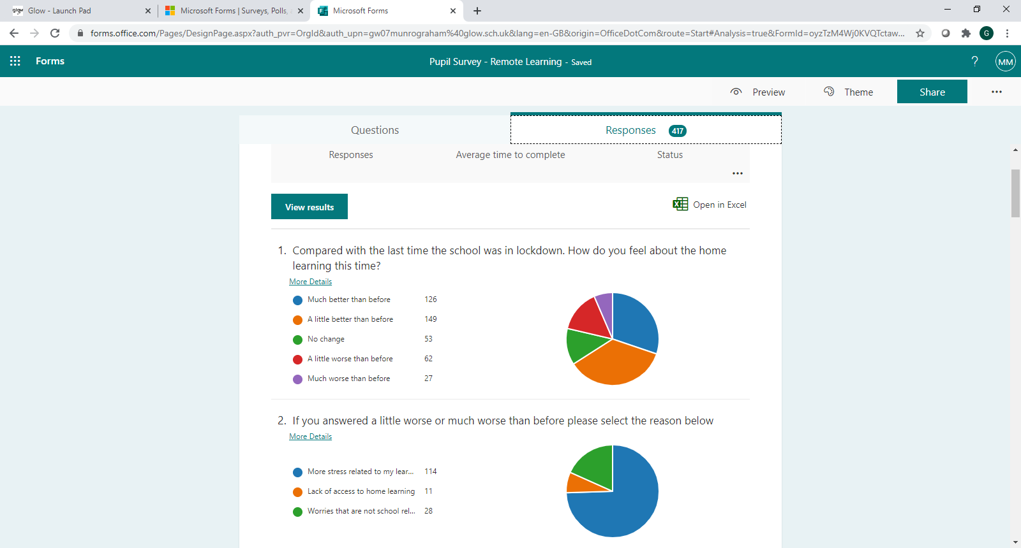

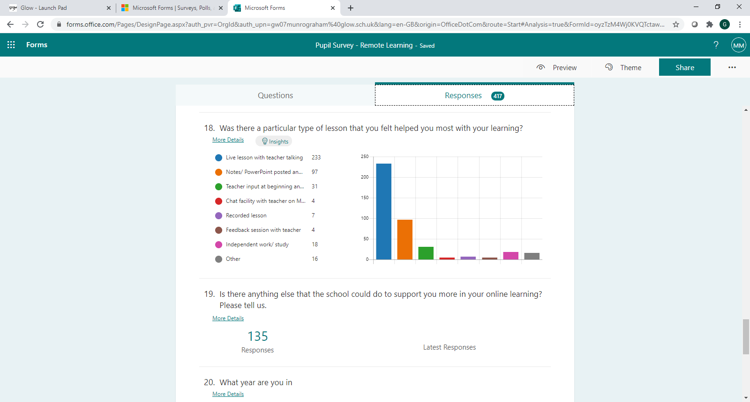

Specific feedback about departments has been given over to them directly to allow them to engage further with young people with a view to making the departmental remote learning even better.

On Tuesday this week we sent out a survey to parents to get your views on remote learning and also on how we can best support you and your child. The survey addressed pupil mental health. We will analyse the results next week and get in touch with those parents who requested a call back.

I also note that Renfrewshire Council sent out remote learning surveys to all Renfrewshire parents on Thursday 28th January. Apologies for two surveys arriving with you in the same week.

**Holocaust Memorial Day – insert from Miss Smith, RE**

Wednesday 27th January was Holocaust Memorial Day with the theme 'Light up the Darkness.' Pupils in S2 RME have been studying a topic on the Holocaust, looking at the way Jewish people and other minorities were treated before, during and after WW2, from the discriminatory Nuremburg Laws to the concentration camps. This week they were asked to learn about the life of Anne Frank. As an additional task, they were asked to light a candle on Wednesday at 8pm to show that they were thinking of the Holocaust victims and those who still experience prejudice today. I've attached just a wee selection of some of the photos our pupils sent back. Really touching!

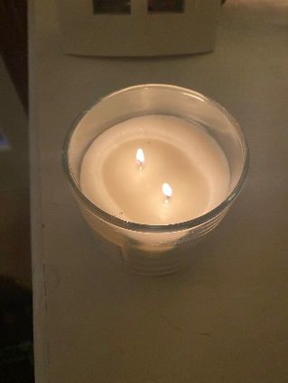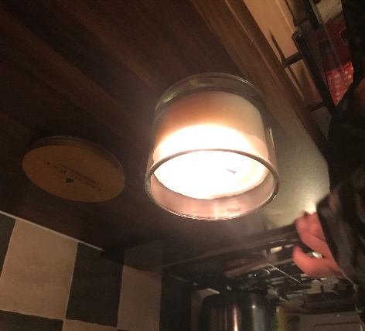

If you would like to view the virtual memorial event that was put together by Renfrewshire and East Renfrewshire Councils to commemorate Holocaust Memorial Day 2021, you can access it here: <https://youtu.be/3-Ml8cbN1G0>

**Career Read Launch – insert from Mrs Carlin, Employability Lead Teacher**

We were part of the Career Ready Launch on Thursday 28th January, with over 400 pupils from a number of schools, and mentors from a wide variety of industries. This programme is for S5 pupils who may lack confidence or have barriers to social mobility.  The programme aims to empower young people by connecting them with the world of work, providing workplace experiences, career insights and a network of support.

We have two pupils on the programme, and they have been matched with Diageo and Renfrewshire Council (IT dept) as mentees. We have one more allocated place to fill and I have sent a text to all S5 parents. Interested families can email me directly : [gw13carlinamanda@glow.sch.uk](mailto:gw13carlinamanda@glow.sch.uk) and I have also attached the link to the Career Ready Programme which parents/carers can read for more info. It is for S5 pupils who will be staying on until the end of S6 as it is a two-year programme. There is a **paid internship** in the summer as well!

<https://careerready.org.uk>

|  |  |
| --- | --- |
|  | [Home - Career Ready - National Social Mobility Charity](https://careerready.org.uk/)  Career Ready is a national social mobility charity which works with employers, schools, and volunteers to support young people across the UK.  careerready.org.uk |

**Keeping in touch**

Please remember that we are here to help.

PT Pastoral will be your first point of contact; however, the office staff will always endeavor to get you through to the most appropriate person. There is also the school enquiries email.

[johnstonehighenquiries@renfrewshire.gov.uk](mailto:johnstonehighenquiries@renfrewshire.gov.uk)

With best wishes to you and your family,



Lynne Hollywood

Head Teacher