Remote Learning Guide for
Parents and Carers

January 2021

Contents Page

Remote Learning Tips 03
A guide to… 06
All of the online resources below are explained in a little bit of detail in this document.
They are each taken, in alphabetical order, from page 6.
Main platforms:

Microsoft Satchel: One Google Word YouTube
Teams (formerly, Show Classroom PowerPoint
my Homework) Excel
Other platforms:

Kahoot Brainscape Poll Forms ThingLink
Everything

Miro Socratic Kialo Edu Khan Quizlet
Mindmaps Academy
Whiteboard.FI

Some links for assistance 16

REMOTE LEARNING TIPS
The guidance below can help us all make the best of new and sometimes unfamiliar remote learning environments. It can help you be ready for some of the more practical aspects of learning from home.

1. Establish routines and expectations
It is important to develop good habits from the start.
Create a flexible routine and talk about how it’s working each day.
Chunk your days into predictable segments.
Help your children to get up, get dressed and ready to learn at a reasonable time.
“Everybody make your bed!”
Keep normal bedtime routines, including normal rules for digital devices.
Adjust schedules to meet everyone’s needs but don’t default to staying up late and sleeping in.
2. Choose a good place to learn
Your family’s regular learning space for occasional homework might not work for extended periods. Set up a physical location that’s dedicated to school-focused activities.
Make sure it is quiet, free from distractions and has a good internet connection.
Make sure an adult monitors online learning.
Keep doors open, and practice good digital safety.
3. Stay in touch
Teachers will mainly be communicating regularly through our online platforms and virtual learning environments (MS Teams and Satchel One).
Make sure everyone knows how to find the help they need to be successful.
Stay in contact with classroom and support teachers, PTs Pastoral and Depute Head Teachers, but please understand it may take a day or two for us to respond.
If you have concerns about remote learning, phone the office on 0300 300 1331 or let Mr Munro know. graham.munro@renfrewshire.school
4. Help students ‘own’ their learning
No one expects parents to be full-time teachers or to be education and subject area experts.
Provide support and encouragement and expect your children to do their part.
Struggling is allowed.
Don’t help too much.
Becoming independent takes lots of practise.
Many social interactions will continue from a distance, but they will be different. You cannot replace them all, and that’s OK.
5. Begin and end the day by checking-in
In the morning, you might ask:
• What classes/subject do you have today?
• Do you have any assessments to hand in today?
• How will you spend your time?
• What resources do you need?
• What can I do to help?
At the end of the day you might ask:
• How far did you get in your tasks today?
• What did you discover?
• What was hard?
• What could we do to make tomorrow better?
6. Establish times for quiet and reflection
For families with children of different ages, and parents who may also be unexpectedly working from home more often, it’s good to build in some time for peace and quiet. Siblings may need to work in different rooms to avoid distraction. Many families will need to negotiate access to devices, priorities for wi-fi bandwidth and schedules throughout the day. Noise-cancelling headphones are an idea. Time each week should be planned for independent, low-stress learning. Reading is fundamental.
7. Encourage physical activity and exercise
Living and working at home, we will all need some room to let off steam. Moving (independently and together as a family) is vital to health, wellbeing, and readiness for learning. It’s a great opportunity to practice exercising ‘alone together’ with digital workouts and online instructors. Set new fitness goals and plan hands-on, life-ready activities that keep hands busy, feet moving, and minds engaged. You may want to think about how your children can help more around the house with chores or other responsibilities. Now’s a good time to think about increasing personal responsibility and helping out.
8. Manage stress and make the most of an unusual situation
We are going through a time of major upheaval to our normal routines and ways of life, and there’s a great deal of anxiety in the world right now. Emotions may be running high, and children may be worried or fearful. Parents may be stressed as well, and children are often able to pick up on this.
Please don’t hesitate to contact your child’s teacher, PT Pastoral or DHT if you need assistance or advice. In these circumstances, it’s often possible to reframe challenges as opportunities: for spending time together, discovering new ideas and interests, investing energy and attention in activities that often get pushed aside by everyday tasks and responsibilities. Experts advise that it’s a good idea to slow down, find beauty, enjoy unexpected benefits, and express gratitude by helping others.
9. Monitor time on-screen and online
Remote learning does not mean staring at computer screens seven and half hours every day. Teachers will aim to build in variety, but it will require some trial and error before everyone finds balance between online and close-space offline learning experiences. Work together to find ways to prevent ‘down time’ from becoming just more ‘screen time’.
10. Connect safely with friends, and be kind
The initial excitement of school being closed will fade quickly when pupils start missing their friends, classmates, and teachers. Help your children maintain contact with friends through social media and other online technologies. But monitor your child’s social media use. Remind your child to be polite, respectful and appropriate in their communications, and to follow normal school guidelines in their interactions with others. Report unkindness and other problems so that everyone maintains healthy relationships and positive interactions.

A guide to the different Apps and Platforms…
Brainscape
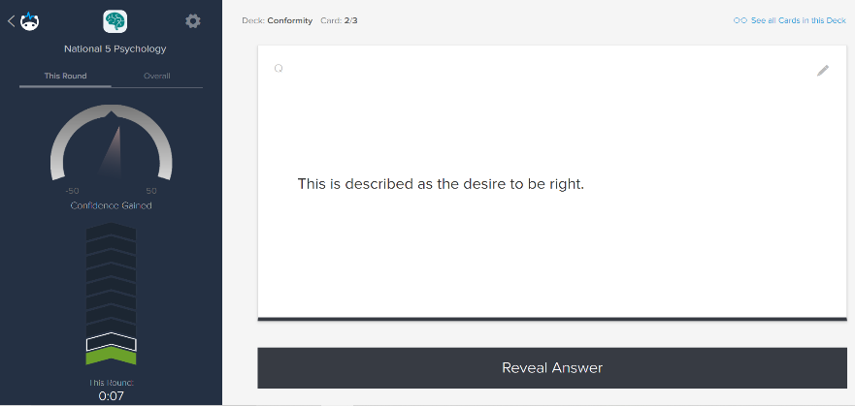
Brainscape is a web and mobile education platform that allows
students to study adaptive flashcards. The website and mobile application allow students and teachers to create electronic flashcards, and to find flashcards created by other users and publishers around the world. The software learns which of flashcards are more difficult for each pupil and brings this flashcard up more often to improve retention of learning. The software records the class on their confidence levels,
which the teacher can view to
plan for targeted intervention.
What the teacher needs :A Brainscape account. (A free basic plan is sufficient)
What the pupils need : Access to the internet. Pupil’s should “sign in” via Google. This does not mean you need a separate Gmail account. After clicking Log In press “Continue with Google” to use your Glow account by changing @glow.sch.uk to @re.glow.scot and your password remains unchanged.
Forms
Forms is an online survey creator by Microsoft, part of Office 365. Forms allows users to create surveys and quizzes with automatic marking. Allowing pupils to get instant feedback in the form of a grade or comment. The data can be exported to Microsoft Excel or the Microsoft Teams “Grades” section.

What the teacher needs :Access through your Glow account. Share each quiz link or post as an assignment on TEAMS/ Google Classroom.
What the pupils need : Access to the internet. Pupil’s should access Microsoft Forms through their Glow accounts or by following the
assignment tab on TEAMS.
Google Classroom
Google Classroom is a free web service developed by Google for schools that aims to simplify creating, distributing, and grading assignments. The primary purpose of Google Classroom is to streamline the process of sharing files between teachers and students. Like Microsoft Teams, Google Classroom is a platform to host the classroom without the physical school building. These platforms have been invaluable for remote learning. Google Classroom facilitates live lessons, resource sharing, assignment issuing, marking and collaboration.
What the teacher needs : Access via Glow, “sign in” via Google by changing
@glow.sch.uk to @re.glow.scot and your password remains unchanged.
What the pupils need : Access to the internet. Pupil’s should access the
Classroom through Glow and “sign in” via Google.
This does not mean you need a separate Gmail account. After clicking Log In press “Continue with Google” to use your Glow account by changing @glow.sch.uk to @re.glow.scot and your password remains unchanged.

Kahoot
I am sure many of us have heard if not used Kahoot! It is a game-based learning platform, used as educational technology in schools.
It’s learning games, "kahoots", are user-generated multiple-choice quizzes that can be accessed via a web browser or the Kahoot app.
Just because we are away from the classroom setting does not mean we cannot still use this platform. Kahoot have recently completed an update which allows you to assign a game for homework. This could be used to flip the classroom ahead of your more structured lesson. Or of course you could take your pupils through a Kahoot as a starter or plenary as a live lesson by sharing your screen on TEAMS/Google Classroom.

What the teacher needs : A Kahoot! account. (A free basic plan is sufficient)
What the pupils needs: Access to the internet & a game PIN. No account required.

Khan Academy
Khan Academy is an American non-profit educational organization created in 2008 with the goal of creating a set of online tools that help educate students. The organization produces short lessons in the form of videos. Its website also includes additional practice exercises and materials for educators. Topics include Math, Art, Computer Programming, Economics, Physics, Chemistry, Biology, Medicine, Finance, History, and more.

What the teacher needs : Press “Log in” and “Continue with Google” – use your Glow
by changing @glow.sch.uk to @re.glow.scot
What the pupils need : Access to the internet & “Log in” and “Continue with
Google” – use your Glow by changing @glow.sch.uk to
@re.glow.scot

Kialo Edu
Kialo is a free tool used by educators world-wide to teach critical thinking, facilitate rational classroom debate and explain controversial issues. This platform is an excellent way to facilitate balanced debate – incredibly helpful for those subjects that are heavy in Higher Order Thinking skills like evaluation and analysis.
Teacher’s can post claims, which pupils can add pros and cons towards the argument. Furthermore, pupils can then rate the evaluative points that have been contributed by their level of impact.
What the teacher needs : Press “Log in” and “Continue with Google” – use your Glow
by changing @glow.sch.uk to @re.glow.scot
What the pupils need : Access to the internet & “Log in” and “Continue with
Google” – use your Glow by changing @glow.sch.uk to
@re.glow.scot. Again, your glow password remains
unchanged. Pupils need to pick a username for this site.

Microsoft TEAMS
TEAMS is a web service developed by Microsoft for businesses and schools. The primary purpose of TEAMS is to streamline the process of sharing files between teachers and students. Like Google Classroom, Microsoft TEAMS is a platform to host the classroom without the physical school building. These platforms have been invaluable for remote learning. TEAMS facilitate live lessons, resource sharing, assignment issuing, marking and collaboration.
What the teacher needs : Access via Glow Portal
What the pupils need : Access via Glow Portal

MIRO
One of many options out there to act as a collaboration whiteboard. Think mind maps. Add colour, sticky notes, and shapes to connect ideas together. Unfortunately, MIRO and others are not free resources. The basic, free, account allows for three mindmaps any more than this requires a premium. Once you have signed up just share your screen with your class and build a mind map with them. Of course, you could do this more simply with Microsoft Word, just without all the bells and whistles.
What the teacher needs : Sign up for a MIRO basic account. Share your screen on
TEAMS or Google Classroom.
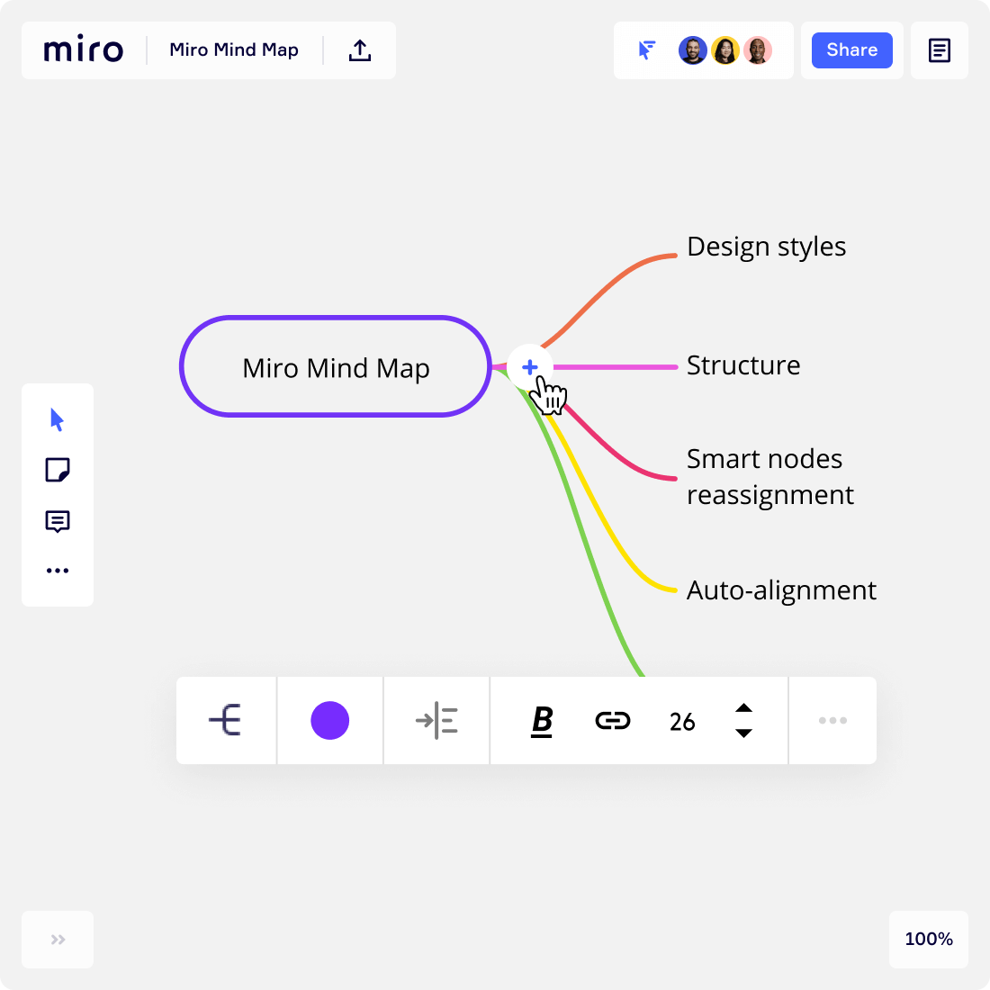
What the pupils need : Access to the internet. Pupils can view your internet
browser, like MIRO, if you share your screen to them via
TEAMS/Google Classroom.

Office 365
I am sure we are all well versed in Office but I have bullet pointed some features for you.
First of all, a reminder, pupils do not need an activiation key for Office on their devices – they can sign in to Office with their Glow account or access the internet based version via
the Glow Portal.
WORD | POWERPOINT | EXCEL | ONENOTE
 |  | 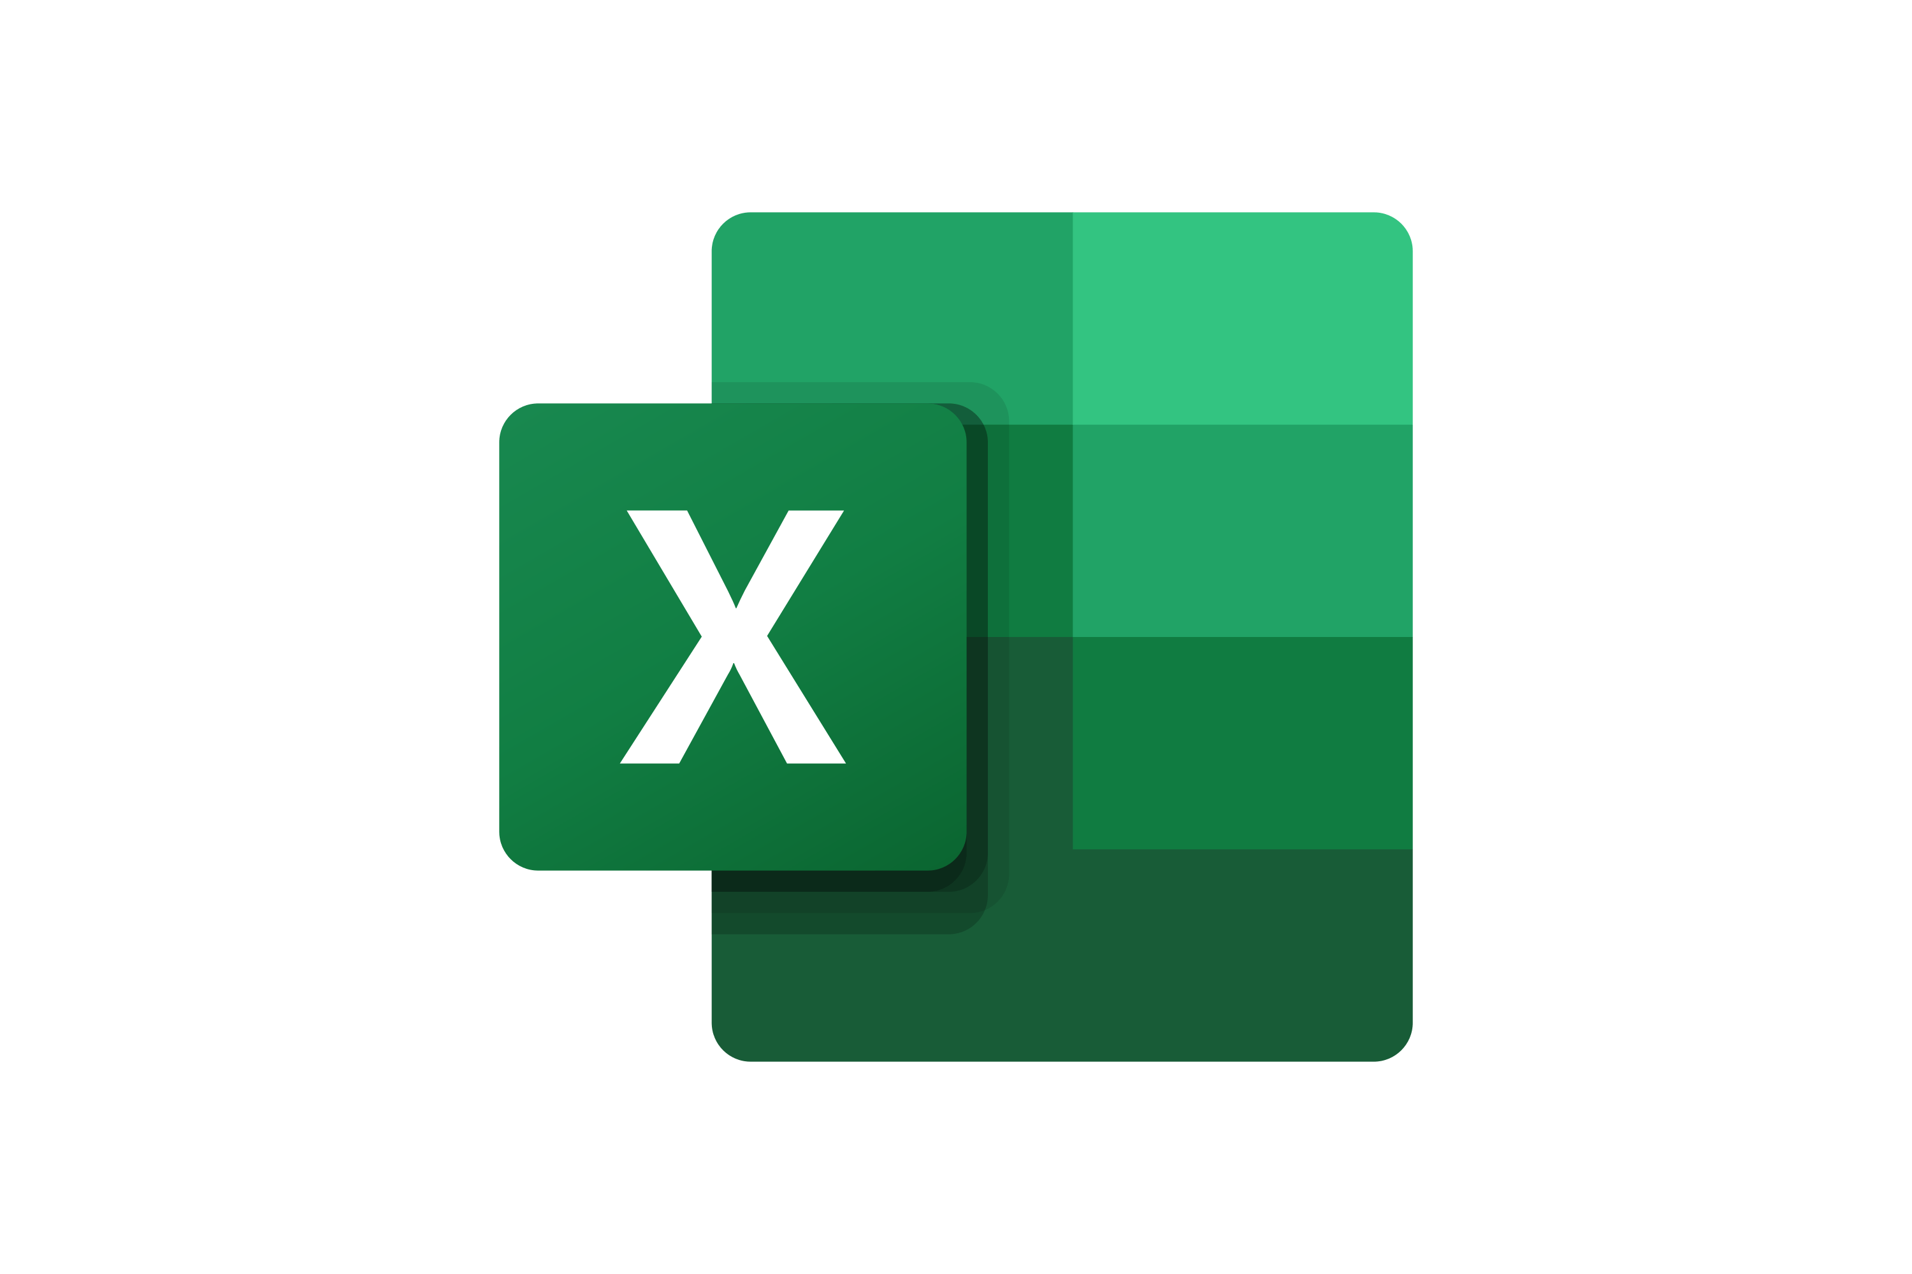
Key features:  The ability to enter and format text, the ability to save and print documents, compatibility with older versions of Word and other software, support for cloud or local use. | Key features:  The ability to create professional-looking electronic slide shows which you can record and present over. | Key features:  The ability to filter and sort data, and then use that data to create tables, charts, and graphs. | Key features:  The ability to organise separate notebooks, each with individual sections within notebooks. It is compatible with a range of digital formats, meaning it is possible to pin multimedia documents as well as simple text.
*Useful tip*
For those pupils who require some additional support the Dictate feature across all of Office 365 allows you to convert speech to text. Just make sure you have a mic attached to your device and be mindful to read over the text to ensure its accuracy. Saying “period”, “comma”, “exclamation point” also inserts the punctation as you go.

Poll Everywhere
Poll Everywhere allows you to host interactive remote meetings anywhere. Capture powerful feedback instantly during virtual classes.

Once you have selected the type of poll you wish to run and posed a question there are several ways an audience can respond to polls:
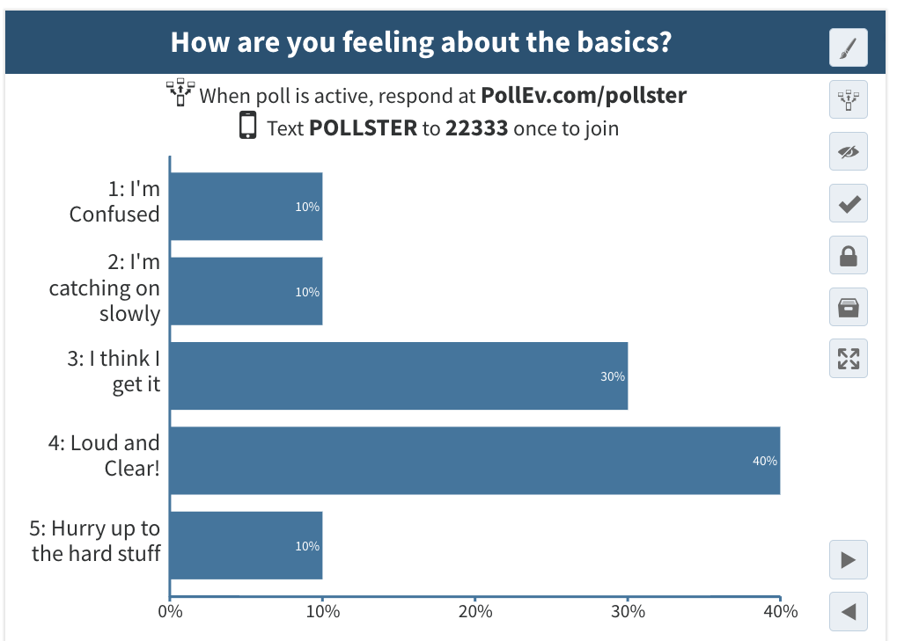
- SMS text message response (standard text rate applies, free if texts are included on phone plan).
- Web responses via the presenter’s
custom PollEv.com polling page.

- Web responses via private link.
The presenter can decide which ways the audience is able to respond to polls.

What the teacher needs : Sign up for a PollEverywhere K-12 FREE account this will
be ample for classes of 30.
What the pupils need: The link for the poll they are to respond to.

Quizlet
Quizlet promises to make simple learning tools that allow for the study of anything. Incorporate Quizlet into your lessons today to allow your pupils to learn with flashcards, games, and learning tools — all for free!

What the teacher needs : Sign up for a Quizlet account.
What the pupils need: The link for the games you create or have found.

Satchel One (formerly Show My Homework)
Satchel One allows you to assign and monitor homework online with a tool that facilitates distance learning, engages students, involves parents and saves teacher’s time.
You can:
Create meaningful homework tasks that engage learners
Actively involve parents by communicating homework details to them
Ensure homework quality and frequency is in line with policy through detailed reports
Enjoy immediate access to distance learning tools.
Be sure to check the community resources here too, to share in best practise.

What the teacher needs : Access via Glow Portal
What the pupils need : Access via Glow Portal

Socratic
Socratic by Google offers a mobile app for students. The app uses AI technology to help students with their homework by providing educational resources like videos, definitions, Q&A, and more. This one may help parents in helping from the home too!
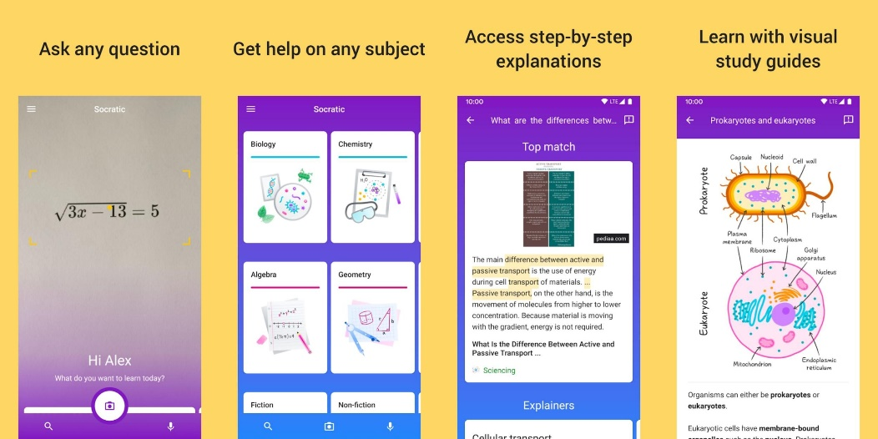

Users can take photographs of questions and the app can scan this question and provide detailed explanations or workings for this question. Although you might not wish to announce this app to the entire class, there are maybe some pupils who can benefit from checking their own work.
What the pupils need : The Socratic app.

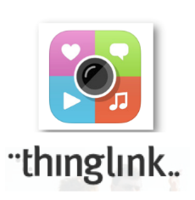
ThingLink
Thing Link promises to seamlessly make your images, videos, and 360 content interactives with text, links, images, videos and over 70 call to actions, creating memorable experiences.
Upload a picture and annotate it with more information. You can then share this image with pupils either by sharing a link or adding the link to a tab on TEAMS.

What the teacher needs : Sign up for a THINGLINK account and share your
creations.
What the pupils need : The link for the annotated media you have created

WhiteBoard FI
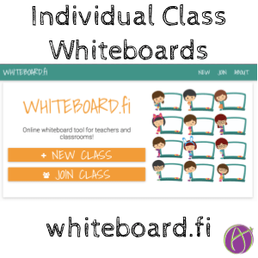
Whiteboard.fi is an instant formative assessment tool for the classroom, providing live feedback and immediate overview over your students. Ask a question and let the whole class answer by using Whiteboard.fi.
It’s takes the “Show Me Board” online.

What the teacher needs : To create a Classroom and share
the code with your class, for free. Classroom’s Q automatically
delete after two hours of
inactivity.
What the pupils need : The link and code to join the
classroom and use the
interactive whiteboards.

YouTube
Well embedded into the fabric of the internet, I am sure we are all aware, YouTube is an excellent resource. Considering that by the time you have finished watching one video, there will be 1,000 more added to the website, there is certainly something for every subject, if not lesson.

Some links for assistance

Help while at home…
Best online learning resources for kids UK 2021 | Mumsnet
Winter startback | Parent Club
The national e learning offer (E-Sgoil) contains live and recorded lessons. https://education.gov.scot/improvement/national-e-learning-offer/
Scotland learns offers a range of ideas and activities to help parents, carers and practitioners support learning at home and during the recovery year. The resources are aimed at a variety of ages. https://education.gov.scot/improvement/scotland-learns/
BBC Scotland online learning help. https://www.bbc.co.uk/programmes/p0934ly5
Help for subject specific…
Our webpage where we house all remote learning materials including MS Team codes. https://www.johnstonehigh.co.uk/remote-learning/
Johnstone High School – Resources for remote learning (glowscotland.org.uk)
Home - BBC Bitesize
SQA - NQ - Past papers and marking instructions

