

Parent Survey Results

January 2021

***Thank you to the 358 people who responded to this survey, your time was very much appreciated.***

***We are trying to get remote learning ‘right’ for our young people and their families, and this survey was an important way of gathering your views. We know our offer isn’t ‘perfect’ but like parents and carers, school staff are doing their best under very challenging circumstances.***

***Thank you for all your comments – we love hearing from you about when we are getting it right. We make sure to pass positive comments on to staff as it is always nice to hear that someone thinks you are doing a good job.***

***But we also need to hear from you when we are getting it wrong, so we can fix it! Therefore, another big thank you to those who took the time to point something out or made a suggestion as to how we can make our offer better.***

***Throughout the survey some parents indicated that they would like a call, and those names have been passed on to Pastoral. However, this will take a few days as they will be doing these calls in addition to their normal duties. If you are waiting on a call and it doesn’t come, please, call us on 0300 300 1331 and we will call you back.***

***Lynne Hollywood***

***5th February 2021***

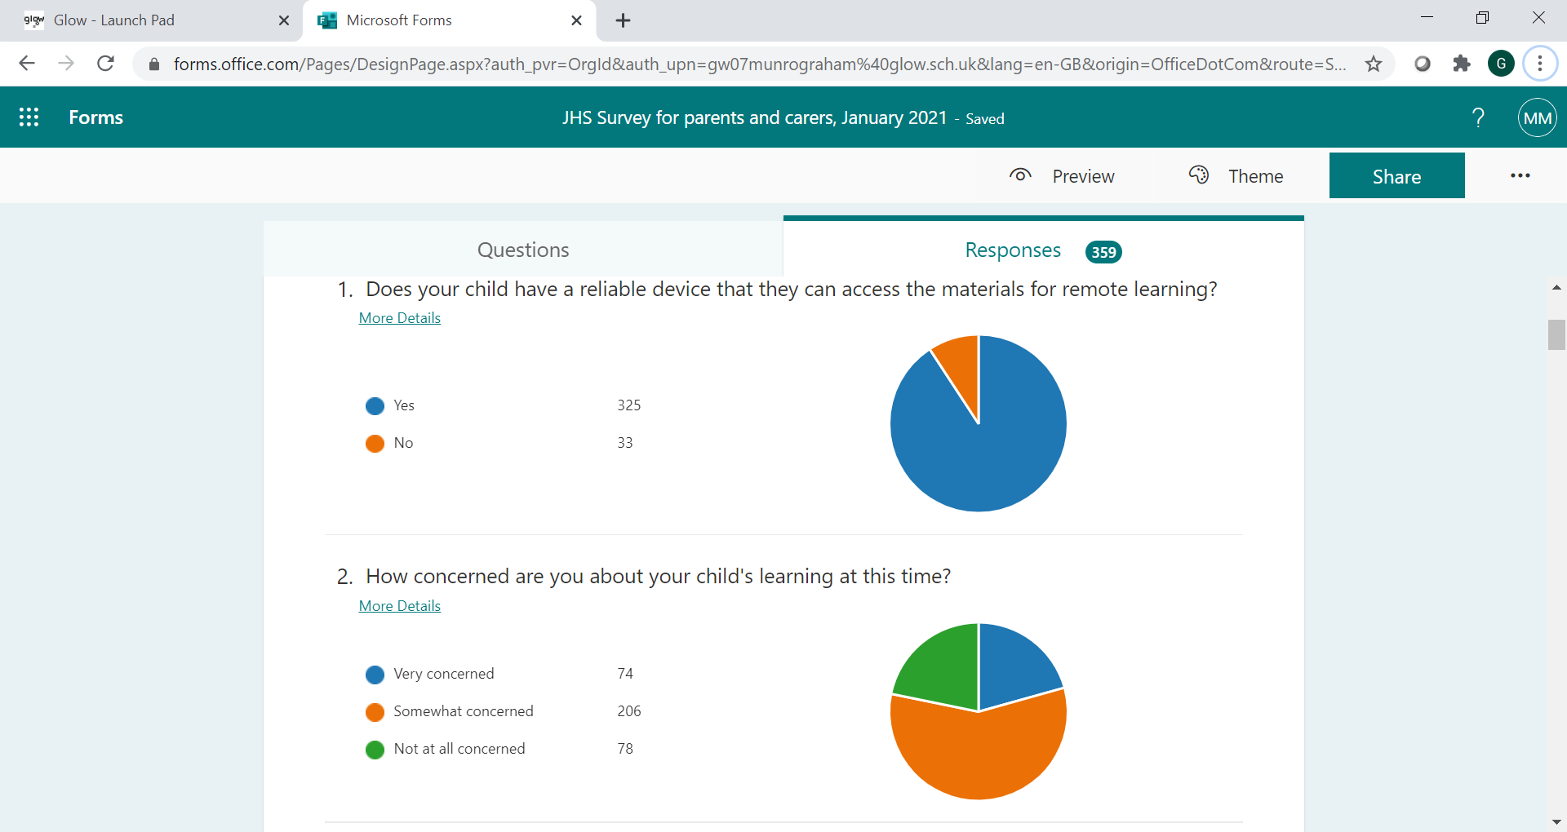

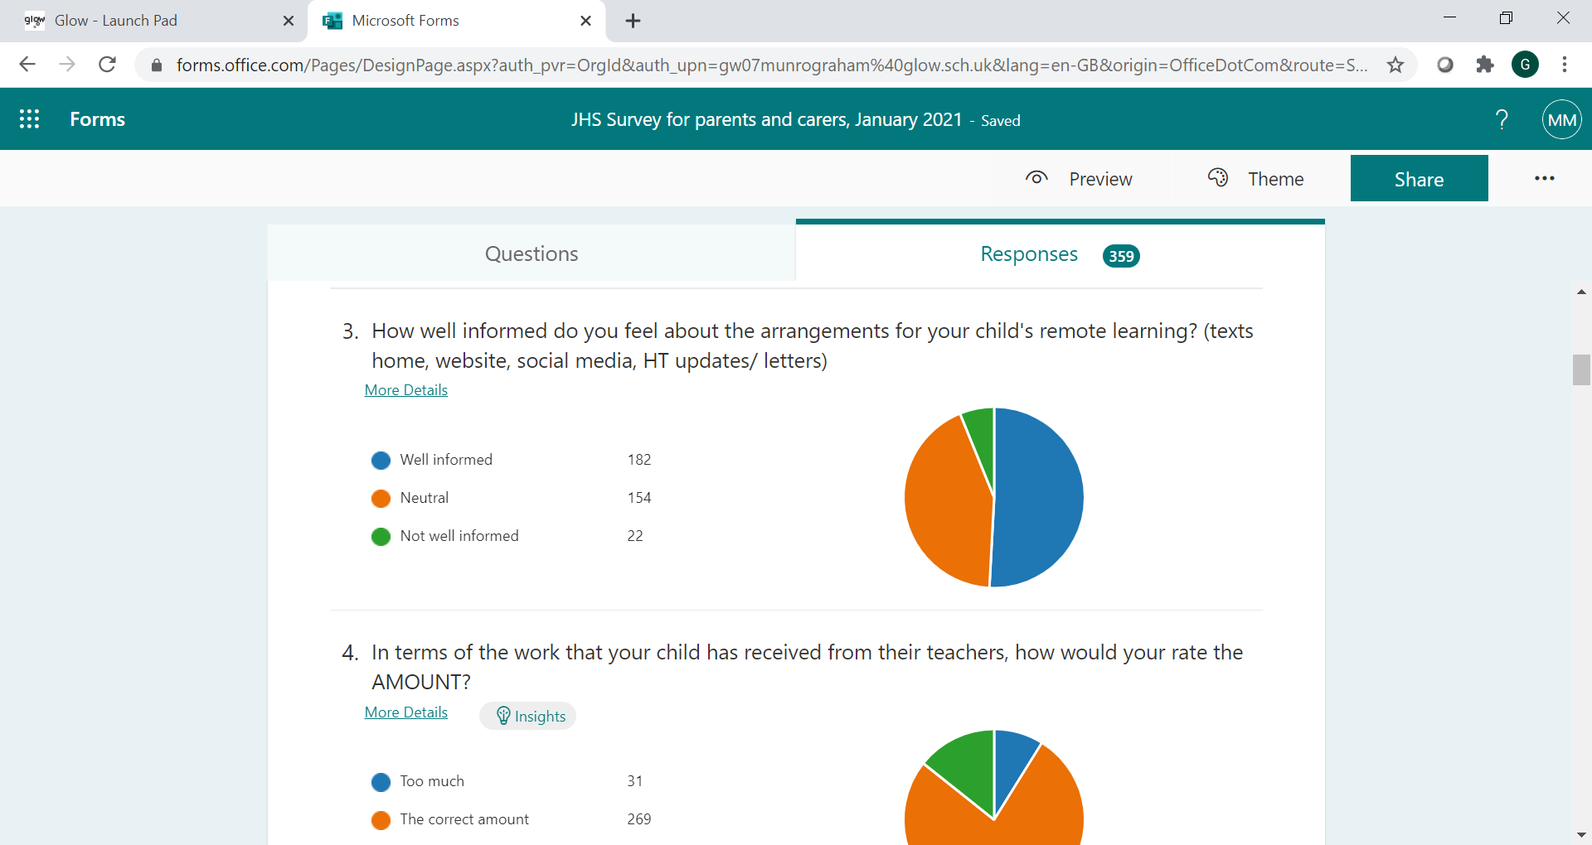

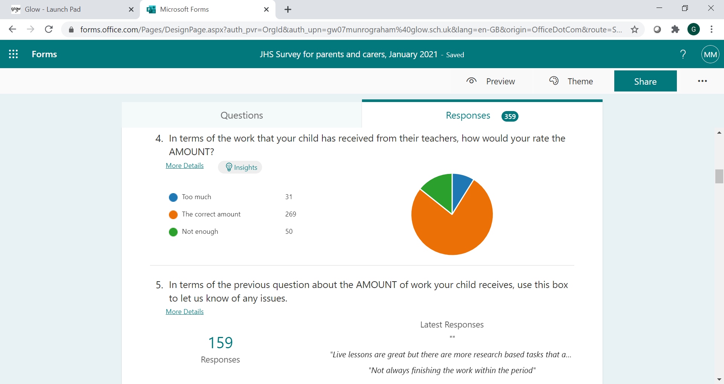

***Q1. We are still working to support the small number of our families who still have issues with their technology.***

***Q2. We realise that parents are concerned about lockdown and remote learning is not a replacement for face-to-face teaching. We are trying hard to make sure our offer is meeting the needs of our learners, which is why we are asking and acting on the views of parents and pupils (we surveyed pupils in January 2021).***

***Q3. We are trying to get the balance right in terms of communication and if you ever have a question or query please call the office or email us.***

***Q4. The amount of work going home is always difficult to gauge but we are heartened that the vast majority of replies told us it is ‘the correct amount’.***

**Q5. In terms of the previous question about the AMOUNT of work your child receives, use this box to let us know of any issues.**

***The responses to this question were in the form of comments, some of which make clear who the family is, therefore we are not listing these. Also, it is a significantly large amount of detail to include in this survey report.   
We have grouped the comments made into the following categories:***

1. ***Live lessons***
2. ***Subject specific points***
3. ***Logistics - the nitty gritty of joining MS teams, satchel one etc***
4. ***Feedback on learning***
5. ***Quantity of work and how it is spread out***
6. ***The engagement of children in the remote learning offer***
7. ***How best to support pupils with additional support needs***
8. ***Mental health issues***

***Where a parent made a comment that we thought we could offer some further clarification, advice or support, we have passed this on to the Pastoral team. Over the next few days (not the holiday weekend) they will be phoning parents to discuss.***

***E.g. parents asking for more live lessons – the current Renfrewshire Council position is that these are voluntary on the part of staff. We are grateful that so many JHS staff do indeed deliver live lessons. Renfrewshire Council is liaising with the unions about this. The expectation is that lessons are as interactive as possible, and this can include using the chat function on MS teams.***

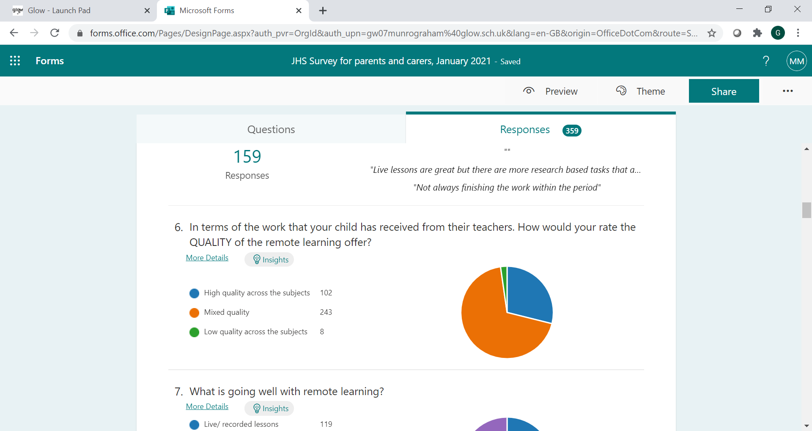

***We have passed this on to staff, along with messages coming from the pupil survey. We are identifying ways in which we can improve the remote learning offer across all subjects.***

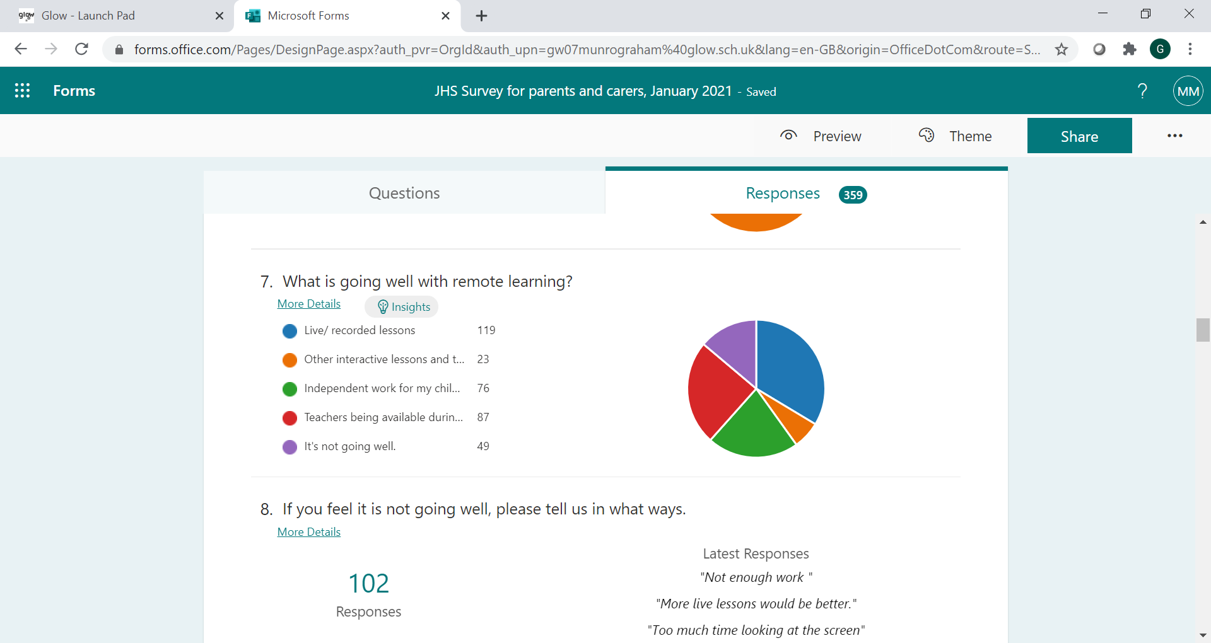

***We know that live lessons score highly with both parents and pupils. Please see previous comment about the voluntary nature of live lessons. We think this is why in question six some parents rated the quality of the offer as ‘mixed’ – some lessons are live, and some aren’t.***

**Question 8 asked for more detail if parents answered that remote learning is not going well. We incorporated these comments along with the rest we received in question 5 (see above)**

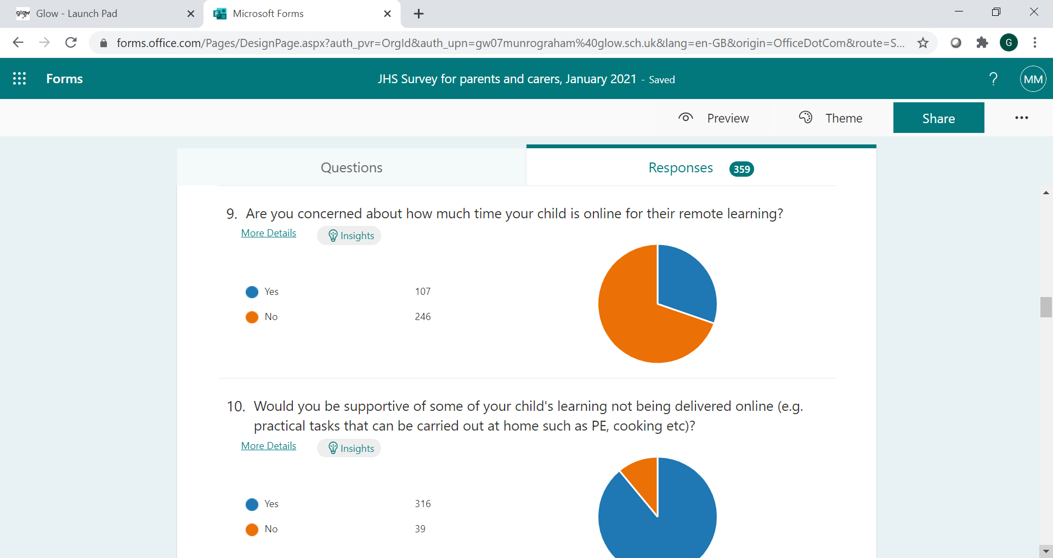

***We also share your concern about the amount of time young people are online or are at a screen. This includes remote learning, and then their screen time afterwards (social media, gaming etc).***

***We are encouraging subject departments to give the pupils a rich mix of activity and this should include time away from a screen. This may be independent study and task completion, reading for pleasure, exercise (PE), practical tasks in the home and kitchen (Home Economics). We are glad that the vast majority of you agree that some ‘learning at home’ tasks such as cooking a family meal together are appropriate.***

11. Do you have any suggestions as to how we can improve our remote learning offer?

***Again, this question allowed parents to comment in some detail. We have taken your suggestions (thank you) and are currently collating these. We will be feeding back these suggestions to staff so that they can review and adjust their approaches accordingly.***

***Principal teachers have been asked to make sure that ‘improving the remote learning offer’ in their department is a regular part of their departmental meetings.***

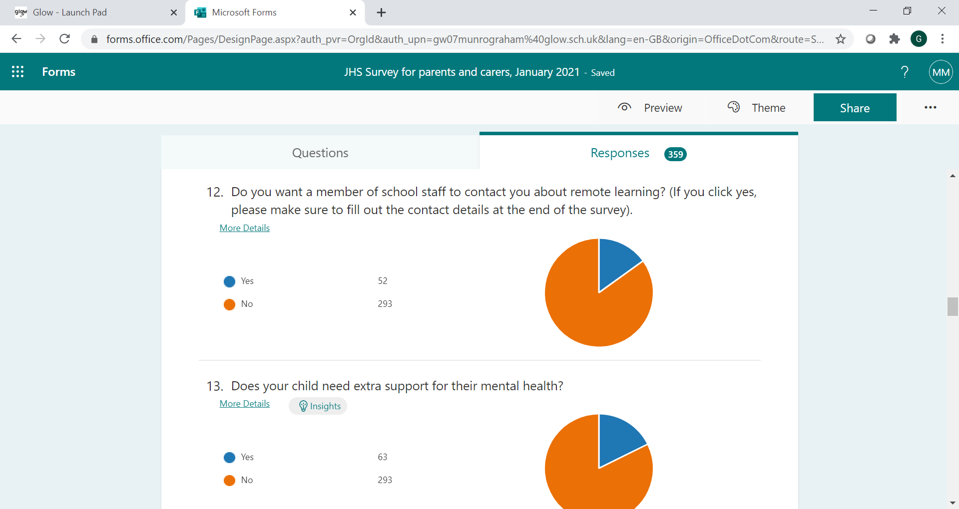

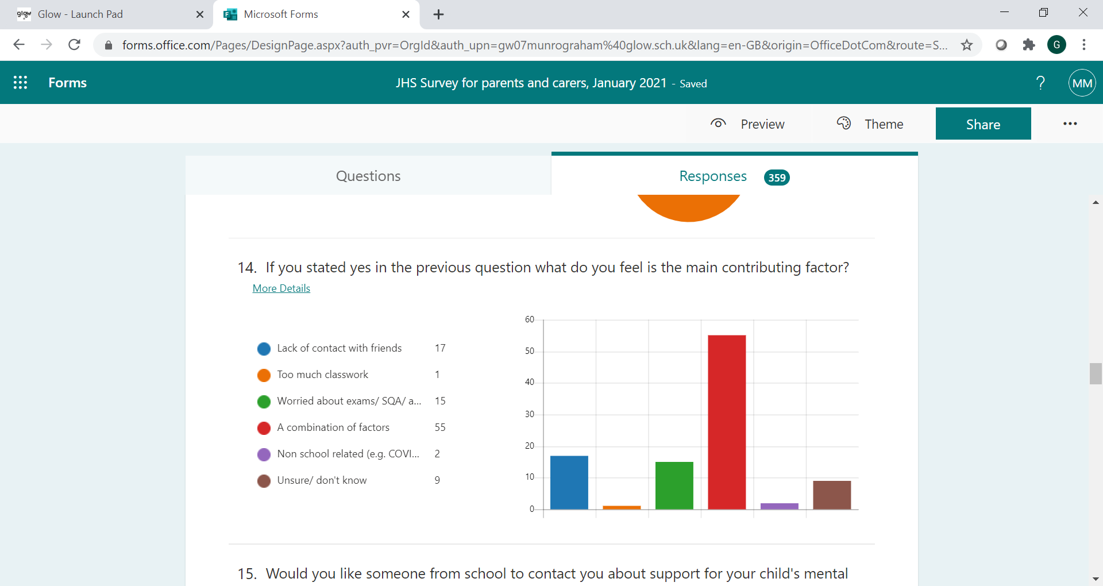

***Qs12+13. We have a list of parents who requested a call back and this has been passed to the Pastoral team.***

***Q14. We asked this question as we wanted to find out what in particular was causing stress and anxiety.***

***We found out that it is not one thing, but a combination of factors. This means that our young people need lots of support, and that every individual child has their own individual, complex needs and worries.***

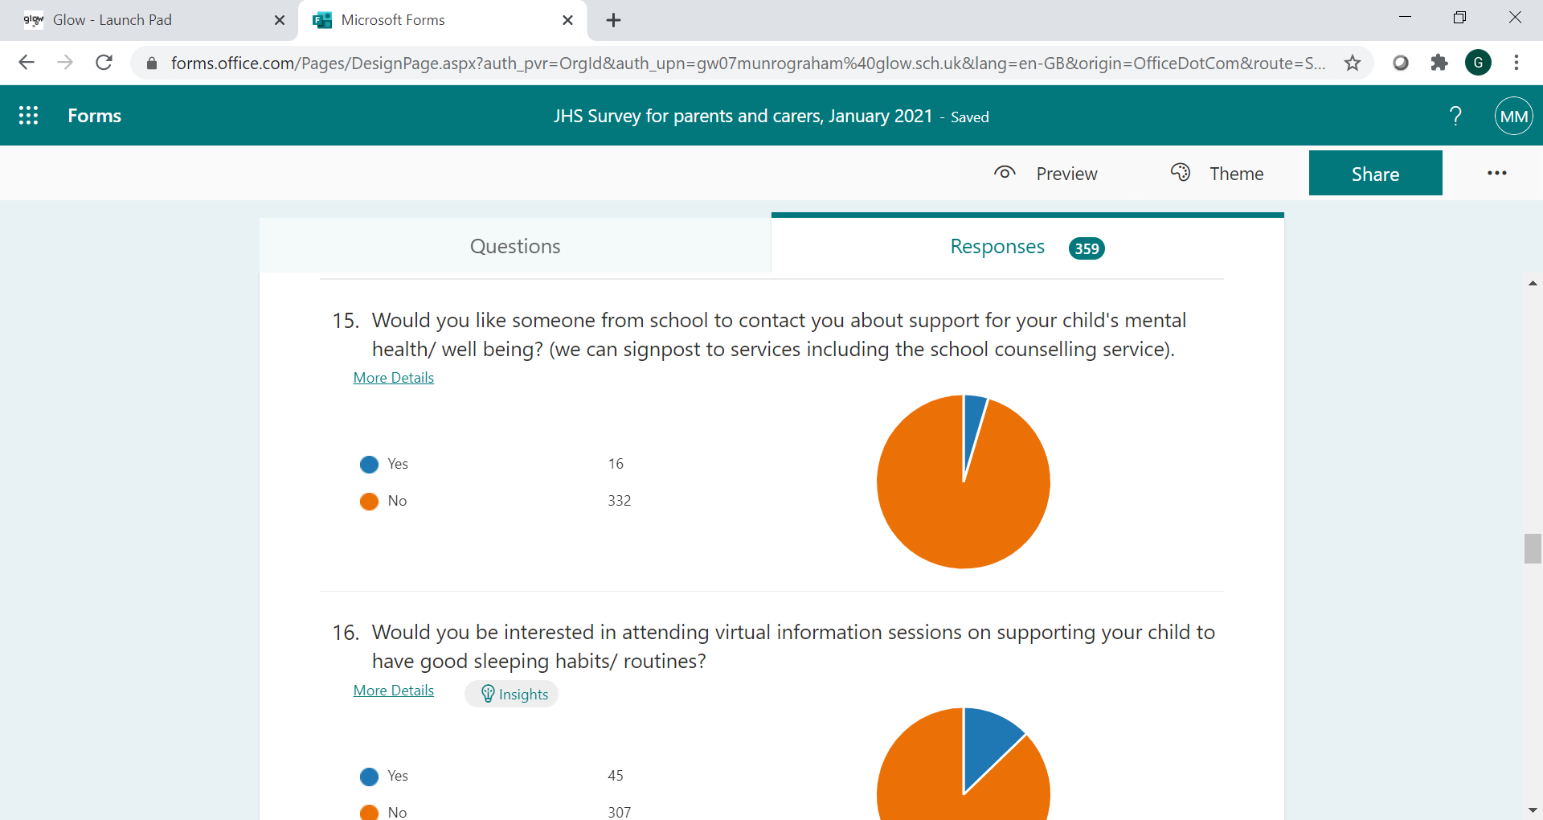

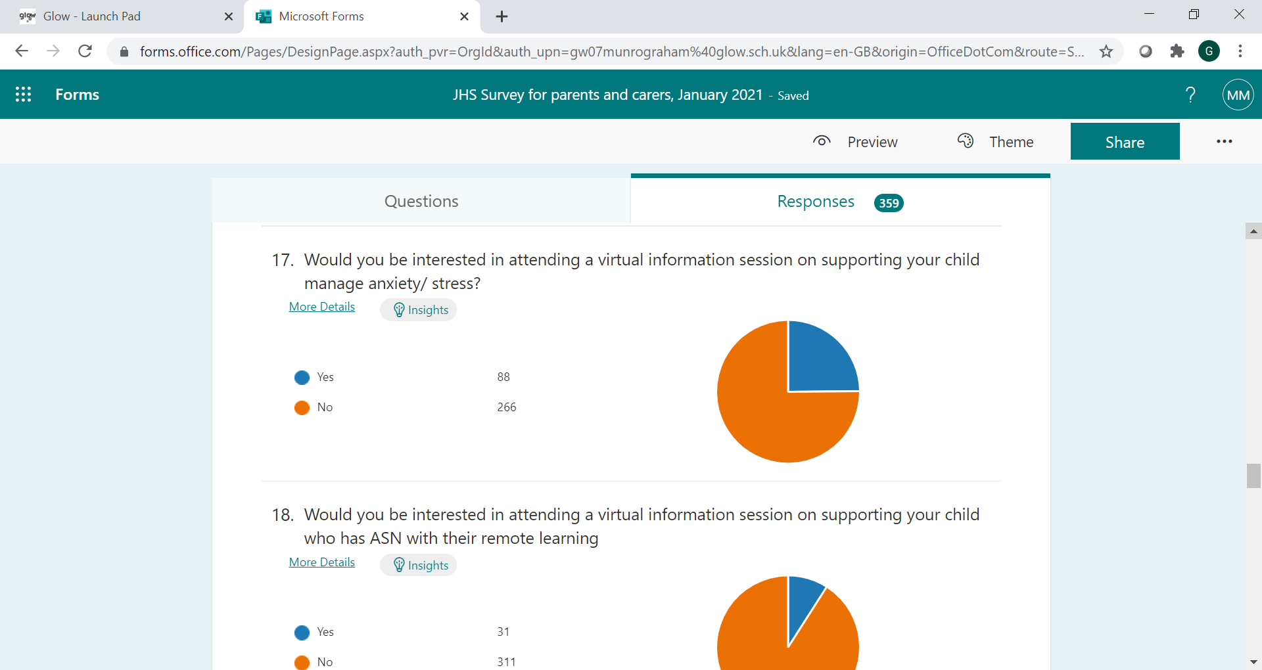

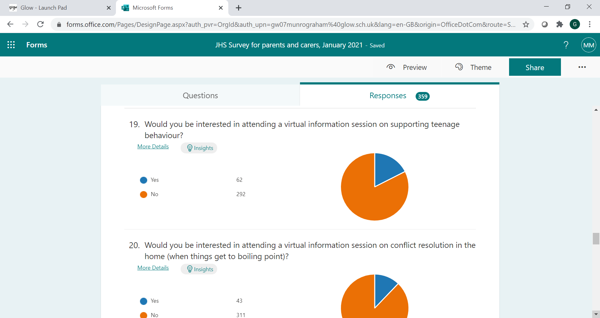

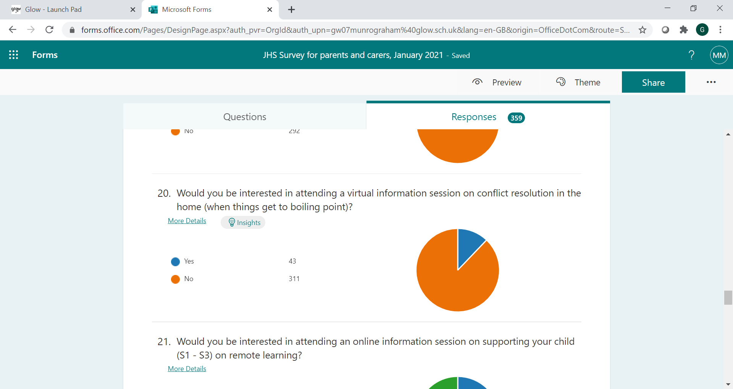

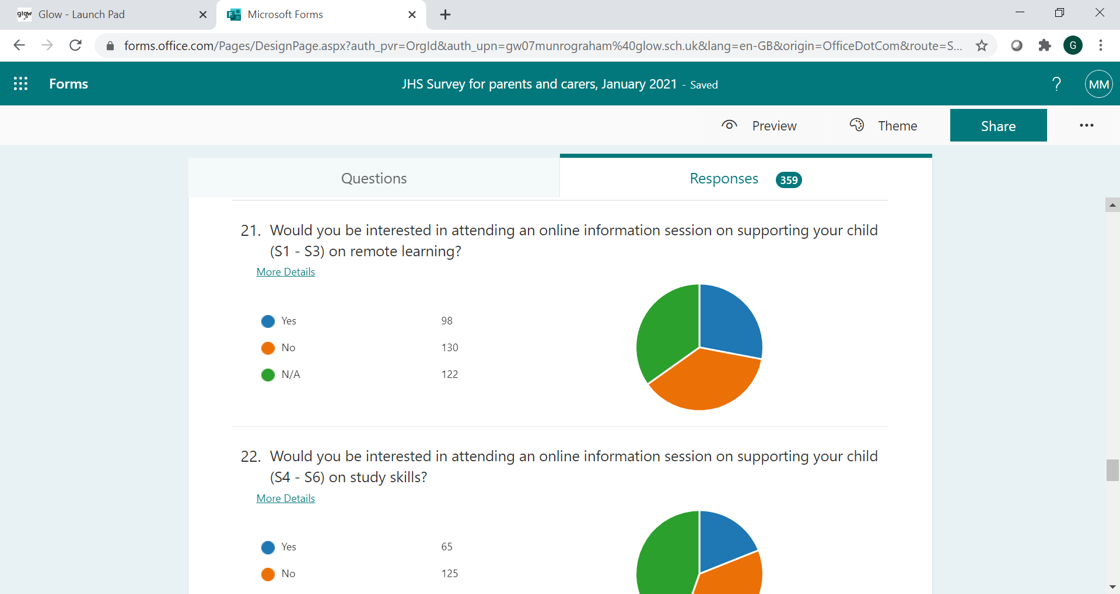

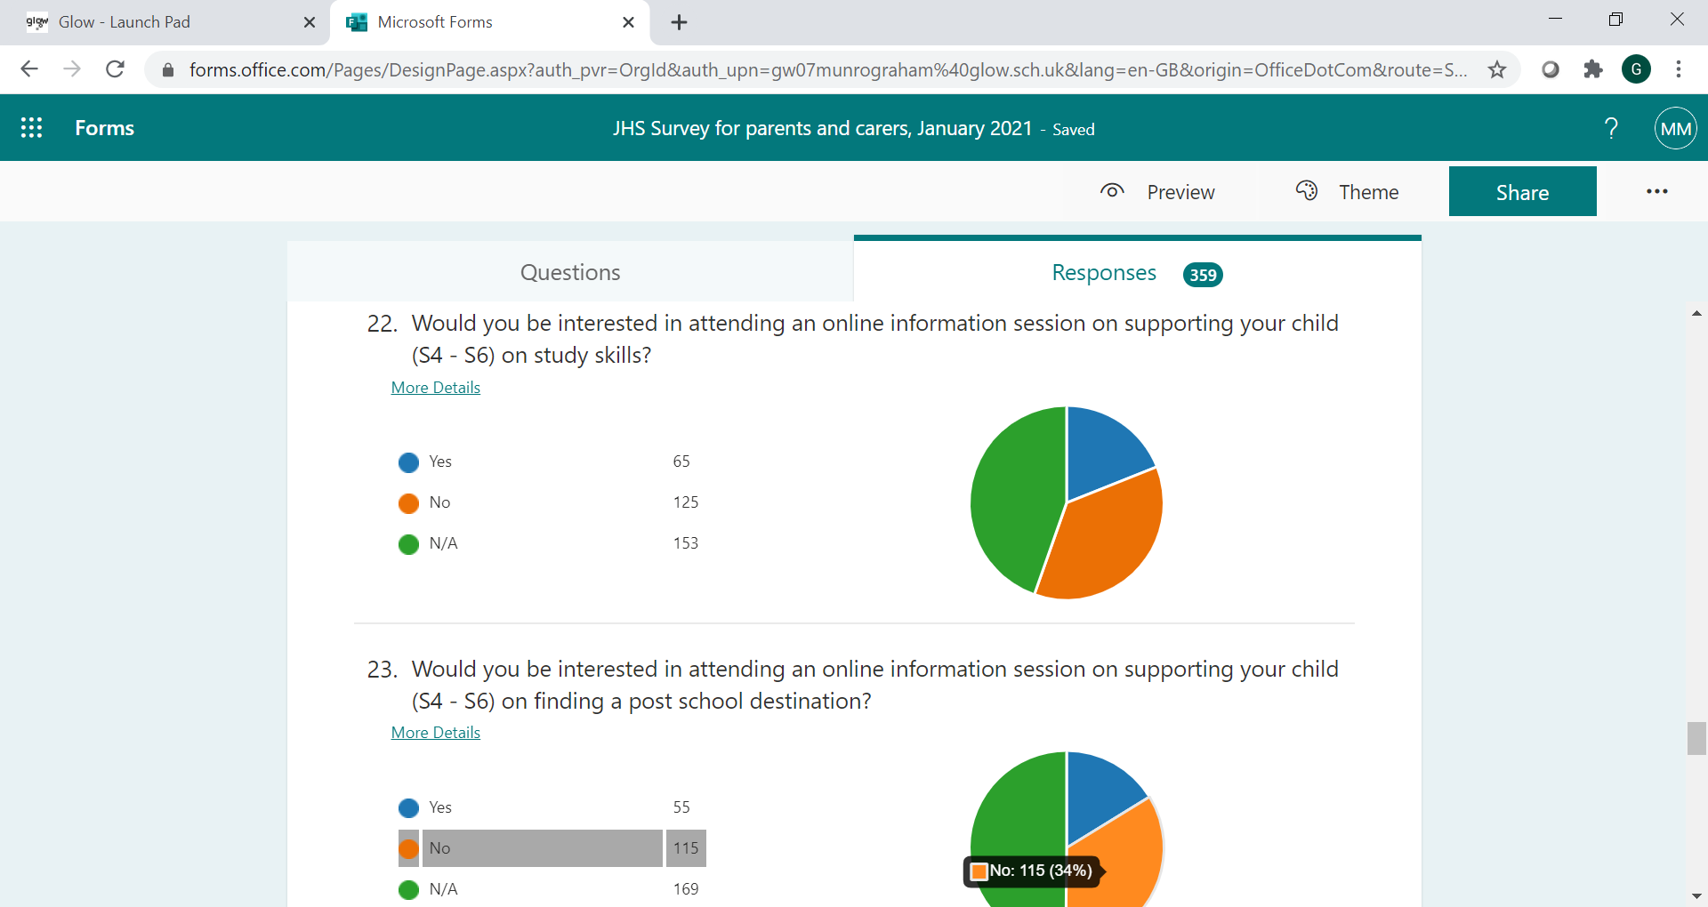

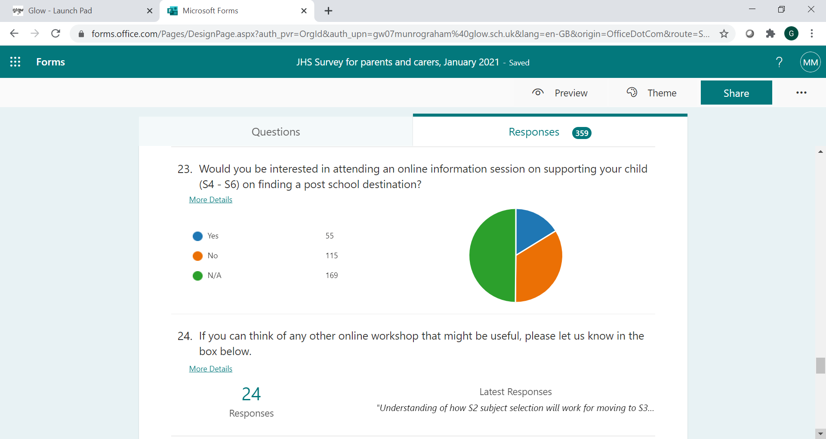

24. If you can think of any other online workshop that might be useful, please let us know

***Q15-24***

***Parents who asked for a call back will be receiving this soon.***

***We were pleased that so many parents expressed an interest in workshops. We have approached staff and are in the process of putting together a catalogue of online sessions, across a range of topics, that parents will be able to sign up to, e.g.:***

* ***Sleep***
* ***Anxiety and stress***
* ***Conflict / behaviour***
* ***Study skills***
* ***UCAS / Uni / College / Jobs***

***More information will come out to you soon.***

***It was mentioned that parents would benefit from an online parents’ evening. Unfortunately, for a number of reasons we are not in a position to do that at the moment, and this was a position agreed across the Renfrewshire secondary schools. We are continuing our reporting system and have increased the number of reports going to parents this year as a result of not having face to face parents’ evenings.***

25. Is there anything else that you feel the school could do to support you and your family at this time?

***Again, parents were able to make detailed comments in this section. Where a specific request for support was made, or an issue was raised, this has been passed to Pastoral.***

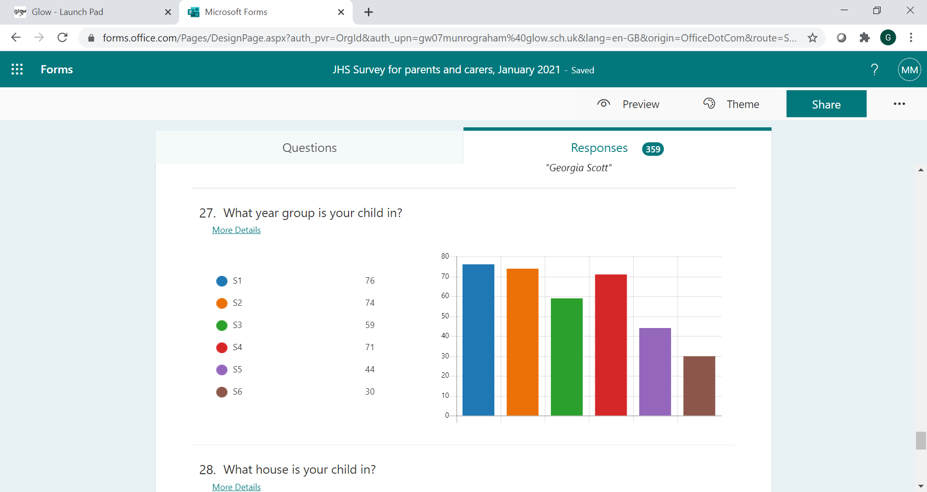

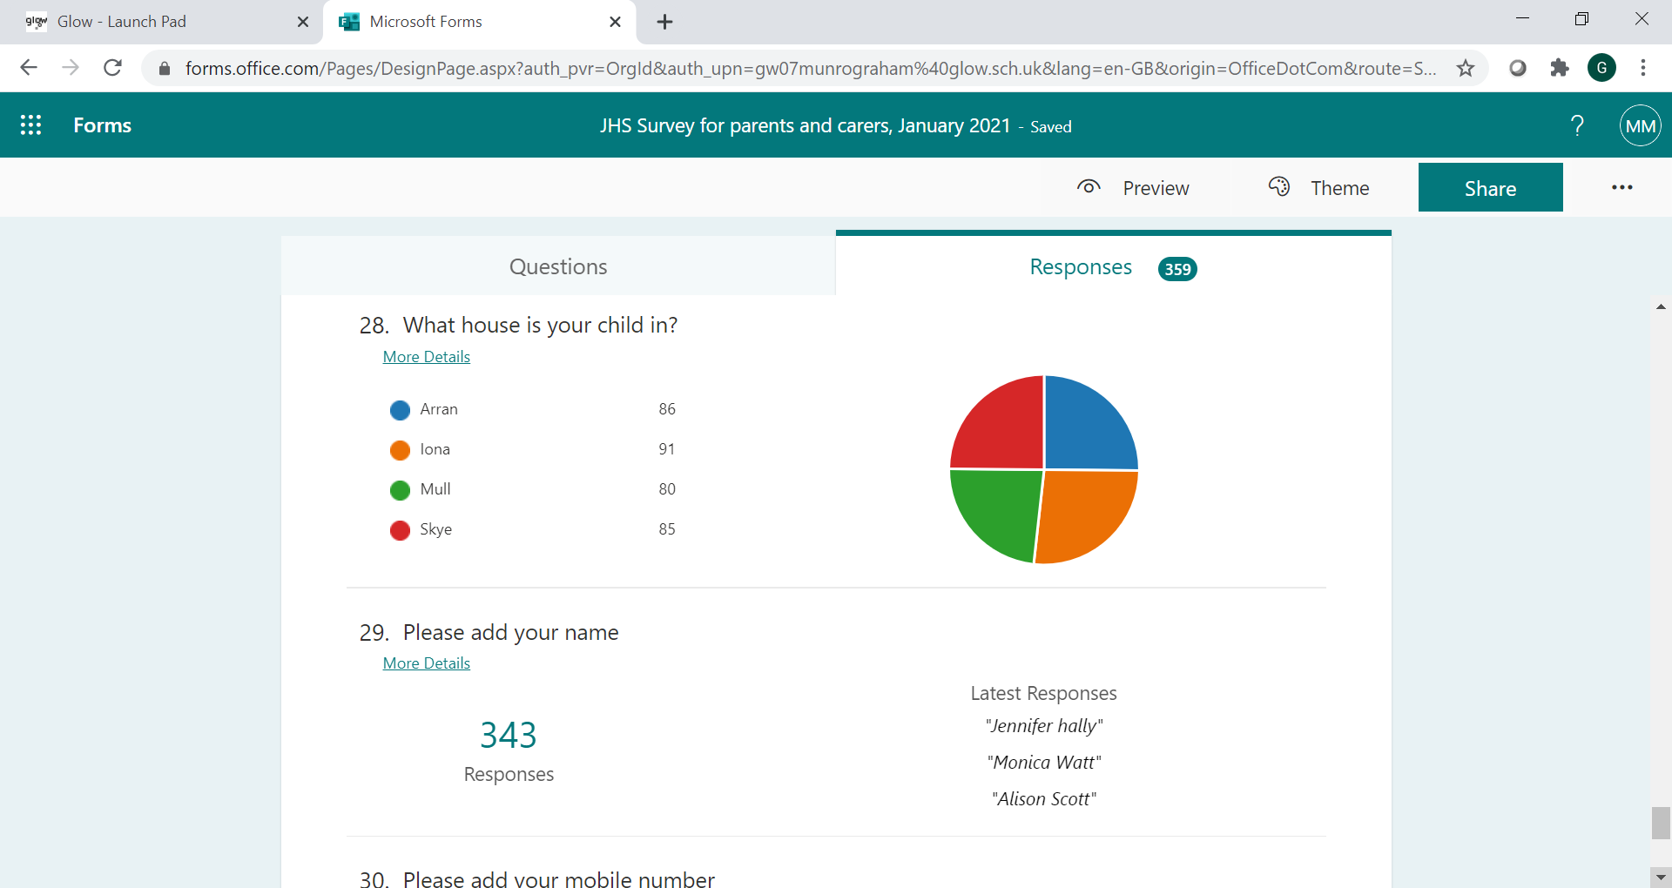

***Qs 27+28.We received a good spread of responses across the year groups and houses.***