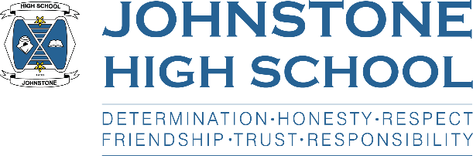

**Head Teacher Update**

**Week ending 1ST April 2021**

Dear Parent / Carer,

I would like to take this opportunity to thank all parents, pupils and staff for the collective effort that has got us through this term. It’s been a hugely challenging time as we adjusted to another period of lockdown, and of course, the closure of the school. I am extremely proud of what our school community has done, and how we have all coped with this adversity. In particular, the young people have been amazing. I hope you all have a restful holiday break with plenty of family time (and not so much screen time!).

We are planning for a full-time return of pupils on the 19th of April, however the final decision will be made by the government based on the most up to date scientific advice. I believe that the decision will be made on the 6th April.

**Based on our hope for a full time return to school on the 19th of April, I would like to remind parents/carers and pupils about the following back to school / health and safety measures:**

* We are going back to normal school times: 8.50am – 3.40pm (2.50pm Wed/Fri) and will be following the normal school timetable
* School buses will operate as normal and all pupils should wear a face covering on the buses
* We are still operating staggered breaks and lunch times to keep the S1-3 / S4-6 bubbles separate
* Full school uniform is expected, and pupils should bring a bag with equipment/jotters to minimise sharing resource
* We are reverting back to entrance via YEAR GROUP DOORS to maintain year group bubbles
  + S1 front door
  + S2 IT door
  + S3 dance studio
  + S4 HEc door
  + S5/6 music door
* Hand sanitising as normal
* Wiping down desks as normal
* Pupils across all year groups S1-6 will be wearing face coverings in classrooms, corridors, social spaces and toilets (unless exempt)
* Top up home test kits will be available for those who are in the programme, and have ran out, two days per week
* Visitor access to the school remains restricted and we are not able to support any unplanned visits. If you need to meet with a member of staff please call in advance, thank you.
* Staff will continue to maintain 2m distancing from each other as far as is practicable, and pupils are requested to keep 2m distance from staff

Other news this week:

Easter school – Ms Cole has posted final arrangements on the school website. Pupils who signed up have been emailed. On the days they are coming in, they do not require to wear uniform, and will be welcomed at the front door where they will hand sanitise and collect a snack. There are posters up highlighting which rooms they are going to.

PLEASE NOTE THAT PUPILS DO NEED TO MAINTAIN 2M SOCIAL DISTANCING DURING EASTER SCHOOL.

This restriction is being lifted, we hope, from the 19th April.

Options - Mr Menzies has a letter written for parents of S4/5 pupils which will be posted out the second week of the Easter holidays. This contains an update on the options process and also has the pupil’s individual interview appointment time. These interviews will take place week beginning 19th April (as per Mr Menzies letter that went along with the options form last week).

**Finally, should any member of our school community test positive for covid over the break, please get in touch with us. Thank you.**

School office: 0300 300 1331.

There is also the school enquiries email:

[johnstonehighenquiries@renfrewshire.gov.uk](mailto:johnstonehighenquiries@renfrewshire.gov.uk)

With best wishes to you and your family for the Easter break,



Lynne Hollywood

Head Teacher