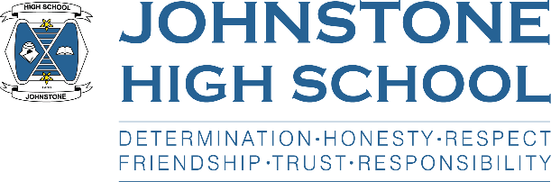Friday 16th April 2021

Dear Parent / Carer,

**FULL TIME RETURN TO SCHOOL**

**19th April 2021**

I hope that you and your family have enjoyed a relaxing Easter break.

I’m sure every parent will be delighted with the news on the 6th April that confirmed that ALL pupils S1-6 would be returning to school full time from Monday 19th April. We are certainly delighted to have our young people coming back to school and look forward to a busy and productive summer term.

I wrote to parents on the 1st of April with the health and safety measures that will be in place from Monday, however I thought it might be useful to confirm these so you can discuss with your child what will be expected of them:

* We are going back to normal school times: 8.50am – 3.40pm (2.50pm Wed/Fri) and will be following the normal school timetable
* In a change from the winter term, pupils across all year groups S1-6 will be wearing face coverings in classrooms, corridors, social spaces and toilets (unless exempt)
* School buses will operate as normal and all pupils should wear a face covering on the buses
* We are still operating staggered breaks and lunch times to keep the S1-3 / S4-6 bubbles separate

10.30am – 10.45am 12.25pm – 1.10pm

11.20am – 11.35am 1.15pm – 2pm

S1-3 are first break on Mon/Tue/Thurs

S4-6 are first break on Wed/Fri

* Full school uniform is expected, and pupils should bring a bag with equipment/jotters to minimise sharing resource
* We are reverting back to entrance via YEAR GROUP DOORS to maintain year group bubbles
  + S1 front door
  + S2 IT door
  + S3 dance studio
  + S4 HEc door
  + S5/6 music door
* Hand sanitising as normal
* Wiping down desks as normal
* Top-up home test kits will be available for those who are in the programme, two days per week
* Visitor access to the school remains restricted and we are not able to support any unplanned visits. If you need to meet with a member of staff please call in advance, thank you.
* Staff will continue to maintain 2m distancing from each other as far as is practicable, and pupils are requested to keep 2m distance from staff

All pupils will receive a brief lesson on Monday morning about these health and safety measures.

Finally, parents of pupils in S4-6 will be aware that the return to school will mean assessment periods for their children as we gather the evidence we need for SQA. Mrs Cole, DHT, wrote to all parents in the final week with details about our approach to assessment in the summer term. This letter was sent home with pupils and is also on our school website.

With best wishes to you and your family



Lynne Hollywood

Head Teacher