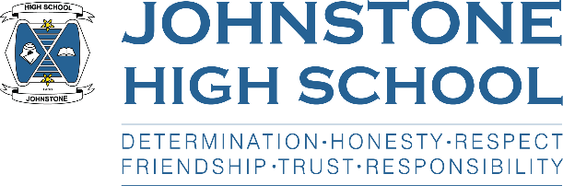**Head teacher weekly update**

**Friday 30th April 2021**

Dear Parent / Carer,

As we approach the long weekend, I would like to take the opportunity to thank the pupils for their hard work and how they are handling the return to school. I realise that lockdown was extremely challenging for our young people, and we are committed to nurturing and supporting them to get back into the routines and expectations associated with school life.

We will continue to remind them about conduct, litter, face coverings and time keeping, but the fast majority of our young people are doing what we ask them, and for that we are very grateful.

Here is the news for week 26 – 30 April 2021:

1. **Pupils attending school next week**

Please remember that Monday 3rd June is a bank holiday and that Thursday 6th May is an in-service day. Pupils should not attend school on these dates.

1. **Parent council**

The next meeting of the parent council will be on Monday 17th May. This will be the AGM and more information will come out in due course.

The parent council chairs across all 11 high schools were invited to an information session on Tuesday 27th April with the Director of Children’s Services, Mr Steven Quinn. I was in attendance along with the chair of the JHS parent council, Mrs McFarlane. Mr Quinn took the opportunity to talk through the Renfrewshire approach to SQA and the ‘alternative certification model’ that is in place across all of our high schools to award grades in 2021.

We will discuss this at the next JHS parent council meeting.

1. **Assessment period three**

Pupils across S4-6 are currently in the middle of their third assessment period in order to gather the evidence needed for SQA provisional grades. The pupils are working really hard and I am so proud of how well they are coping with their workload and time management. Any pupil requiring help or support should speak with their class teachers or Pastoral Support teacher.

In order to support their studies, pupils should be attending raising attainment booster classes that are on after school, remotely, each week.

1. **S6 / leavers update**

Mr Munro has put out a MS form survey to the S6 to get their views and suggestions about graduation which will take place on the afternoon of Wednesday 23rd June.

My thanks to the parent council who have agreed to fund a meal for the pupils straight after graduation. We are now deciding with the S6 if it is pizza or a chippy!

1. **Awards ceremonies**

We are currently exploring how we can offer a S1-3 awards ceremony in June. Our initial plan is for a virtual event on the evening of Tuesday 22nd June.

We are also discussing a S4-6 senior phase awards ceremony taking place early in the new session (August/September). This is a change to how we do things in Johnstone High School, however a September awards ceremony is commonplace across many other high schools.

We will be in touch with more information when we have firmed up plans, and of course, any plans made at the moment are subject to ongoing covid restrictions.

Have a brilliant long weekend!

With best wishes to you and your family,



Lynne Hollywood

Head Teacher