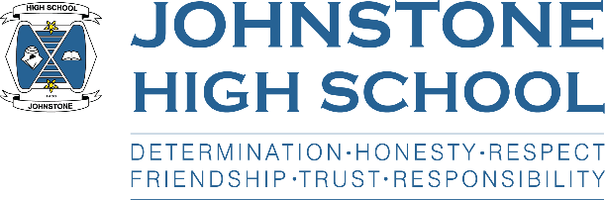**Head teacher weekly update**

**Friday 21st May 2021**

Dear Parent / Carer,

**Here is the news for week 17-21 May 2021:**

1. **Parental Support**

I am becoming increasingly concerned about some of our young people across a range of areas. These areas include:

* The wearing of appropriate school uniform
* Persistent late coming; arriving to school after 8.50am
* Requiring a face covering, sometimes on multiple occasions throughout the day
* Littering in school and in the surrounding areas
* Silly and occasionally reckless behaviour in school and the local community; recently we have taken calls about behaviour at the shops, on the school bus and even in the local park.

Whilst I appreciate our pupils are adjusting back into school life and that re-establishing rules and expectations can be a challenge, I would very much appreciate parental support across these areas. We will continue to support our pupils to the best of our ability and remind them about being responsible citizens at school and in their communities.

1. **Forthcoming in-service days and holiday dates**

For your diary, please note that pupils should not attend schools on the following dates:

Monday 31st May holiday

Tuesday 1st June additional in-service day

Monday 7th June additional in-service day

School closes for the summer break at 1pm on Friday 25th June 2021.

1. **SQA Update**

Our final period of assessment is 24th May – 4th June. Ms Cole has put together the final assessment calendar for the pupils and this has been issued (and is available on the website). Please note that online booster classes are available in the evenings for most subjects and we **VERY MUCH ENCOURAGE (!)** pupils to attend these sessions especially when they have assessments coming up.

We are acutely aware that this is a challenging time for our senior pupils. We are so proud of how they are coping with the SQA’s alternative certification model, or ACM. As you will be aware, we require to collect evidence of **demonstrated attainment,** under ‘exam conditions’ which covers all areas of the course in order to give our young people a provisional grade. This inevitably means an assessment burden on our pupils however we are now getting nearer to the end of the process and some subject areas are telling us that evidence gathering is already complete for their learners. The end is in sight.

The two in-service days in June will be given to staff to focus entirely on SQA. Our staff will be working collaboratively with their subject colleagues across the 11 Renfrewshire high schools to continue to verify the validity of the assessment tools they have used and moderate the marking of pupil assessments. If required, we are also able to use the local authority’s moderation team for an additional check on an already robust process.

Finally, we are working closely with the local authority to agree a method of letting the pupils know their provisional grades on the last week of term.

1. **Primary transition**

Unfortunately, we are unable to bring our associated primary school pupils together on the last week of term, as we had hoped, for a traditional ‘2 day’ visit. The decision has been made at a local authority level that to minimise Covid risk, primary school bubbles should not be mixed. Although disappointing, we understand why the decision has been taken and health and safety must be the priority.

We are now working on plan B for the 21st and 22nd June which will still see the primary pupils come up in individual school groups for a short block of outdoor activities, alongside an online curricular offer.

We are now very relieved that we made the decision to bring up our primary schools after hours on Wednesdays over the month of May for a tour of the building and a Q+A session – it’s been very nice to meet them 😊 We have only one week to go, and look forward to seeing pupils from Auchenlodment and Thorn after school on Wednesday 26th May.

1. **S4-6 Leavers**

A letter has been put on the website about how we are managing the process for S4-6 leavers this session, given that there are continuous assessments and as a result there is no official leaving date. You can also access the letter below, and I would recommend that parents have a read to make sure your S4-6 child’s attendance is an accurate reflection of their final weeks in school. Thank you.

<http://www.johnstonehigh.co.uk/wp-content/uploads/2021/05/Leavers-letter-May-2021.docx>

With best wishes to you and your family,



Lynne Hollywood

Head Teacher