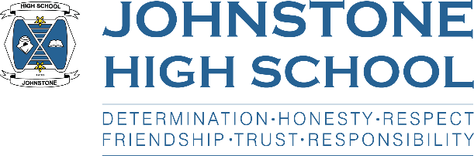**Head teacher weekly update**

**Friday 11th June 2021**

Dear Parent / Carer,

**Here is the news for week 7-11th June 2021:**

1. **Covid Update**

As I mentioned last week, the school has sadly now been subject to contact tracing largely due to community transfer over the two previous long weekends. The vast majority of young people self-isolating are now back or are due to return on Monday 14th. We have a process in place to pick up on any young person S4-6 who has missed out on an assessment; these will be completed on their return. If there are any concerns, please contact your child’s pastoral teacher.

1. **Timetable news**

On Monday we begin the 2021/22 timetable. Pupils will come into school via their normal doors and be directed to a classroom with the rest of their teaching class (e.g. 3Arran 2, 5Mull1 etc) for period one only where they will be issued with their timetables.

Again, any issues please contact Pastoral in the first instance. Thank you.

1. **SQA Update**

School staff have been working hard over the past two weeks to mark and moderate assessment evidence generated throughout assessment window four. We are now at the stage of checking this information and passing it through school and local authority quality assurance.

We are likely to be issuing provisional grades via letters handed to pupils on the last week of term. More information will come to parents and learners on this.

1. **Director Visit**

On Tuesday Steven Quinn, Director of Children’s Services, visited the school to check-in with staff and to speak to the senior management team about how our young people are progressing given the pandemic and the SQA alternative certification model.

It was a very positive and productive visit and Steven acknowledged our brilliant pupils and hard working staff.

1. **Parent council AGM**

On Tuesday 8th we had our final parent council meeting of the session. Please remember that all Parent Council materials are stored on the school website, once minutes of meetings etc. have been approved.

My thanks in particular to parents who are leaving the group after many years of dedicated support of the school. We wish you and your S6 leavers all the very best for the future.

1. **National Childhood Day / Scotland Euro Match on Monday 14th June**

Today is national childhood day, and as a result all classes covered a 10min lesson on this and the work of the NSPCC. One of our pupils, Chantelle, is a national ambassador and we are delighted to help her raise awareness and funds for this very worthwhile cause.

Therefore, on Monday 14th pupils can wear something Scotland-related and donations will be gratefully received for the NSPCC. I have given staff permission to put the Scotland v Czech Republic match on during class time (kick off 2pm) as it is the first time in 23 years that the men’s first team has qualified for a major tournament – none of our children have ever seen their country play at this level! Please note that I have told staff if any pupil wishes to progress with work, they should be given the facility to do so.

I just hope it’s not another 20+ years until they see Scotland play at a World Cup final!

With best wishes to you and your family,



Lynne Hollywood

Head Teacher