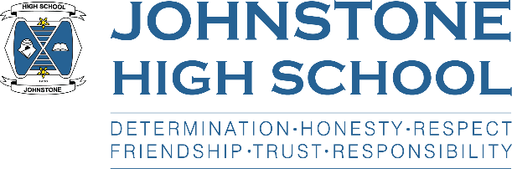**Head teacher weekly update**

**Friday 18th June 2021**

Dear Parent / Carer,

**Here is the news for week 14-18th June 2021:**

1. **Timetable news**

On Monday we began the 2021/22 timetable. Timetable change is always an anxious time in school (particularly for Mr Menzies, the timetabler!) as we run through a complete week and make sure there are no issues with it. At time of writing – Friday p6 – the new timetable has gone without a hitch and staff and young people have enjoyed the opportunity to meet their new classes prior to the summer holiday.

Moving timetable at this stage has also allowed Mr Menzies to meet with those pupils who had a question or query about their classes prior to the new school session starting. He was busy at the start of the week but this has now tailed off. The final step in timetable 2021 is for us to welcome our newly appointed staff who take up post in August.

1. **SQA Update**

We are now at the final stages of the alternative certification model for awarding SQA provisional grades.

Once our processes have been approved by the local authority, we will be issuing pupils with their provisional grades, along with information about how their grades were determined and the appeals process.

We are planning on putting the results in a sealed envelope and issuing these to pupils towards the end of the school day, early next week.

1. **The final week of term**

Next week there is a busy programme in school:

Monday/Tuesday - we welcome p7 in blocks (and in separate primary school bubbles) for

outdoor PE and science lessons. They are also getting virtual lessons back in their primary schools from secondary colleagues throughout these two days

Wednesday - we welcome back S6 at the end of the day for their graduation event

Thursday - PE sports tournament for all year groups.

Pupils should wear PE kit to school on Thursday

Friday - in-class virtual interhouse games and we close at 1pm for the summer holidays

1. **Next session**

Advice came through to all schools from Scottish Government this week to help guide our planning for the new session in August. Specifically, this referred to Covid mitigations. The advice coming through at the moment is that schools should not remove their health and safety measures as we don’t know, nationally where we will be in August. They have made it clear that as soon as it is deemed safe, we can start to relax some of the measures we currently have in place.

There will be more guidance coming out towards the end of the summer holidays and I will write to parents before the new term starts for pupils on Monday 16th August.

1. **Team up to clean up**

Well done to Miss Semple and her merry band of intrepid social subjects pupils who have done a sterling job over the last few weeks cleaning up the school grounds and local neighbourhood areas. I am delighted to tell you that environmental charity, Keep Scotland Beautiful, has awarded us their Summer Clean Hero Award!

1. **Duke of Edinburgh**

Mr Brooks along with other volunteer staff has led two DoE teams on expedition this week. This is great news as the pandemic had called a halt to all DoE work and was delaying pupils from getting their awards. The weather just about held up for them and I hope that they had a positive and memorable experience.

1. **Befriending**

Well done to the 54 new S6 who took part in befriender training on Wednesday with Miss Wilkie, Miss Wilson and other staff volunteers. This programme gives our young people the skills and strategies to successfully support the new S1 when they join us in August. I am very proud of them for volunteering for this important leadership role.

With best wishes to you and your family,



Lynne Hollywood

Head Teacher