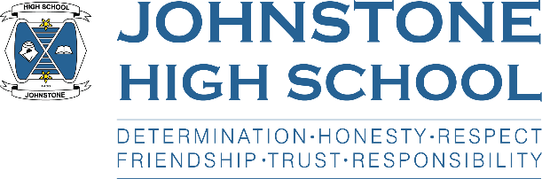**Head teacher weekly update**

**Friday 20th August 2021**

Dear Parent / Carer,

A warm welcome back to all parents, staff and pupils, and especially to our new S1. We have had a great first week back and I am delighted to report that everyone has settled into the routine of high school. S2-6 have got about their business with new timetables and new classes, and S1 have coped brilliantly navigating about the school with the help of our lovely S6 befrienders. Everyone is looking smart in their school uniform and I would like to thank parents for your ongoing support of the school in this regard.

For the benefit of new parents, each week I will endeavour to give you an update on school life, along with any items of news that you need to know. This week, however, I appreciate there has been a huge amount of information coming to you from the school, so this first weekly update of session 2021/22 will be relatively brief.

1. **Covid Update**

There are changes to contract tracing that means schools are no longer involved in identifying close contacts and therefore whole classes are no longer required to self-isolate. However, a key part of this approach is that pupils take part in LFD testing twice per week and these are available in school on Tuesdays and Fridays.

Furthermore, any pupil who is a close contact of a positive case, providing they are asymptomatic and get a negative PCR test, can return to school.

Finally, if any pupil has covid type symptoms, they should not come to school – please book a PCR test.

1. **Parent information packs and returns due**

This session S1 pupils had the usual data pack sent home in an envelope, however S2-6 parents had their packs emailed and we are encouraging ALL parents to access parent portal through the council website (you will need a My Gov account). The annual data check can be accessed through parent portal, as will report cards throughout the session.

In terms of the returns that are due in, please fill out the parent survey that was text to you this week. This is a ‘one stop shop’ to capture all the back-to-school info that we need. Thanks.

1. **Timetable news (S4-6)**

Mr Menzies has been working with the seniors on renegotiations this week. These were far fewer in number due to last session’s alternative certification model for SQA grades. Most pupils now have their timetables sorted, including college and advanced highers. If there are any remaining issues pupils should see Mr Menzies asap.

1. **SQA Update**

You may have seen in the media that SQA exams are scheduled to go ahead this session, albeit with contingency plans around the gathering of assessment evidence should there be the need for another school closure. When we find out more information on this, we will make sure this is passed on to parents.

1. **School calendar**

We are currently working on putting together the school calendar. There is potentially a change to the final May holiday, which may be moved to coincide with the Queen’s jubilee holiday – the final decision will be with elected members at Council and again, we hope to get the calendar out to parents as soon as possible.

1. **School Captains (S6)**

We will be speaking to the S6 pupil group about applications for Captain positions next week, and the recruitment process will start soon after.

1. **HPV vaccinations**

These will be taking place on 3rd September for S2 and S3 boys and girls (letters went out from public health last session). There will also be a catch up for S4-6.

With best wishes to you and your family,



Lynne Hollywood

Head Teacher