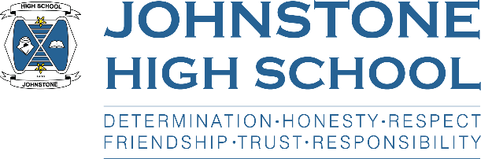**Head teacher weekly update**

**Friday 27th August 2021**

Dear Parent / Carer,

I hope that families have had a pleasant and productive week, enjoying what might be the last of the beautiful summer weather. As ever, school life continues at a pace.

Here is the news for week 23-27 August 2021:

1. **Reminders about school expectations**

As we get into the swing of the school session, a small number of pupils are needing regular reminders from staff about the following matters:

* **Uniform**: pupils should not come to school in PE kit. We expect uniform to be worn as normal.
* **Late coming**: all pupils should be at school for 8.45am as lessons start at 8.50am
* **Littering** in the school grounds
* **Face masks**: the school is issuing a huge number of disposable masks to pupils every day. This is really costly and very damaging to the environment.

1. **Covid Update**

We have a very small number of cases in JHS and parents were text with a link to the new ‘warn and inform’ letter last Friday. This can also be located on the Council website.

1. **Parent information packs and returns due**

Please make sure that you have returned your child’s information / slips – either via paper copies to the office or via the survey that we text parents. The most recent reminder text was Thursday 26th.

We are delighted with the high numbers of returns, especially as this is our first year going electronic rather than paper copies. My thanks to those who have responded…and for those still to do so, the survey will close on Monday 30th August (thank you).

1. **Litter picks**

The school is planning to take part in the council’s Spotless September campaign; therefore some pupils may be taken out of class to participate in a litter pick of the school grounds / local community. We are keen that pupils give something back to the local area and strongly believe that local activity is an important way we can support the climate change agenda.

If you do not want your child to take part in (very occasional) litter picks, please ensure you complete the survey referenced above.

1. **Fire drill**

We had a planned fire drill on Friday afternoon, and I am very pleased with how the pupils responded to this. Great behaviour and cooperation from the young people, and we were able to evacuate the building well within the allocated time. Great job!

1. **S6 News**

UCAS – S6 pupils will be working with Mr Munro next week to register for UCAS.

Captaincy – we have received 25 applications for captain and vice-captain roles. The recruitment process will start next week.

1. **Vaccinations**

The entire school community (pupils and staff) will have the opportunity to take up the flu jag on the 20th of October. Pupils will be getting their NHS letter via PSE next week – please look out for it and return it to school asap.

Similarly, HPV jags will be taking place on 3rd September for S2 and S3 boys and girls (letters went out from public health last session). There will also be a catch up for S4-6. Pupils being vaccinated should wear a short-sleeved shirt, if possible.

1. **LFD (lateral flow device) home testing kits**

S2-6 who have handed in a consent form can pick up stocks of kits every Tuesday and Friday at interval.  
S1 have been given consent forms to take home. These should be handed into the office, or Mr Munro DHT. Once we receive consent forms, pupils in S1 can also collect their kits twice per week.

1. **Parent Council**

The next meeting of the parent council will take place on Monday 6th September at 7pm in the school staffroom. This is our first ‘in person’ meeting since February 2020 😊

With best wishes to you and your family,



Lynne Hollywood

Head Teacher