Johnstone High School 

Beith Road

Johnstone

PA5 0JN

Tel: 0300 300 1331

[www.johnstonehigh@renfrewshire.gov.uk](http://www.johnstonehigh@renfrewshire.gov.uk)

johnstonehighenquiries@renfrewshire.gov.uk

12th August 2021

Dear Pupils, Parents and Carers,

**NEW SESSION 2021/22: Covid Update from JHS**

**(please read this in conjunction with the letter sent yesterday by Steven Quinn, Director of Children’s Services)**

I hope that you have had a pleasant and relaxing summer break and that you are looking forward to the start of the new school session on Monday 16th August. As promised, this letter contains the covid update that was unavailable when I wrote to parents in July with the usual back to school arrangements (uniform etc).

Please be assured that the ongoing safety and wellbeing of our pupils, their families and our staff remains our top priority. This letter will detail our arrangements for returning our pupils back to school and will illustrate how we have put in place the necessary safeguards contained in the most current guidance from the Scottish Government and Renfrewshire Council. Please note, the current guidance is not significantly different from the measures we were operating in June, and the Government has committed to reviewing it in 6 weeks’ time.

This letter will cover the following areas, and I would be grateful if you could discuss these with your child in advance of their return to school:

1. First week back arrangements
2. Support for new S1 pupils
3. Testing
4. Transport and parental drop-offs
5. Beginning and end of the school day
6. Entry to the school building
7. Breaks and lunchtimes
8. Period changeovers
9. Ventilation
10. Physical distancing
11. Face coverings
12. Absence and illness
13. Changes to contact tracing and self-isolation
14. Hygiene measures
15. Parent/visitor access to the school
16. School events
17. Curricular and extra-curricular provision
18. **First week back arrangements**

All pupils will return on Monday 16th August at 8.45am (doors open) for an 8.50am start. Pupils should enter via their year group doors (see below), and there will be posters directing them which classrooms to attend for period one. During Monday period one, all pupils will have a health and safety briefing to go over our arrangements. They will also be issued with a copy of their timetable. Lessons start as normal Monday period 2.

1. **Support for new S1 pupils**

As we were unable to provide our normal three-day visit for the P7s, we understand our new S1 pupils may be a little anxious on their first day with us. Please be reassured that we will look after them and will have everything in place to ensure they have a smooth, supported start to high school.

**On their first day, S1 pupils will be welcomed from 8.40am onwards at the front door and escorted to the canteen/assembly hall.**

For the first weeks of term S6 befrienders will chaperone the new S1 from class to class and S1 will use the canteen for breaks and lunchtimes.

Pupils will be dismissed at 3.40pm as normal at the end of the first day. At that point, any young people travelling on school contact transport will be accompanied by staff and S6 befrienders to the bus bay.

Parents/carers of S1 pupils, please note the start and end times of the school day:

Monday, Tuesday, Thursday 8.50am – 3.40pm

Wednesday, Friday 8.50am – 2.50pm

1. **Testing**

All Renfrewshire parents were text a link to a letter during the summer holidays from Head of Schools, Gordon McKinlay. This contained information about the Government testing programme for school pupils. The Scottish Government strongly encourages secondary pupils and staff to resume lateral flow device (LFD) testing prior to resuming school on the 16th, and then twice weekly, throughout the school session.

JHS pupils had the opportunity to collect stocks of LFD kits before the holidays, and we will make these available again once school resumes (we will make also make arrangements for new S1 pupils). In the meantime, LFD kits can be sourced from local pharmacies.

1. **Transport and parental drop-offs**

Home to school bus transport provided by Renfrewshire Council will continue as normal for eligible pupils. Pupils MUST wear a face covering on the school bus. No food or drink should be consumed while on a school bus. We have also been told that pupils should sanitise their hands before boarding the contract buses. For pupils travelling on public transport, please follow Scottish Government guidance on face coverings and physical distancing.

If arriving to school by car, in accordance with Renfrewshire Council guidance, please park as far away as possible from the building to avoid congestion. With the exception of ASN taxis, at the start and end of the school day **there will be no car access up the hill to the school carpark or front of the building**. In accordance with national guidelines, please consider walking or taking another form of active travel where possible.

1. **Beginning and End of the school day**

A warning bell will go at 8.45am to signal to pupils that they should start making their way to class via their year group door. Doors will open at 8.45am – please note that pupils will not get access inside the building until this point. Therefore, it is very important that pupils wear outdoor clothing appropriate for the weather.

Two minutes before the end of the school day, a bell will go to dismiss the basement and ground floors (HE, IT, SS, Music and Tech). This will allow approximately 40% of the pupils to exit the building before the next bell goes to dismiss the remaining 60%. Again, this is to ensure a safe and orderly school exit and minimise congestion.

Staff will be on hand to support young people at the bus bay. As previously mentioned, for the health and safety of our pupils, cars should park some distance away and there will be no vehicle access up the hill.

1. **Entry to the school building**

Our covid-secure procedure for pupils entering the building at the start of the day, end of interval and the end of lunchtime, is as follows:

* S1 and staff will enter by the main door at reception
* S2 will enter by the door at IT
* S3 will enter by the door at the Drama studio
* S4 will enter by the door at HE
* S5/6 will enter by the door at Music

Staff will be at these doors at these times to ensure a safe and orderly entry into the building. **Pupils will hand sanitise on entry to the building** and will be encouraged to sanitise regularly throughout the day. Hand-sanitising stations have been placed throughout the school and staff will also have portable bottles of sanitiser at each door entrance.

1. **Breaks and lunchtimes**

Unfortunately, we are still unable to provide a food service before school.

Please note that **first years should not leave school grounds at lunchtime** and older pupils who choose to do so should discuss this with their parents and carers first. Older pupils who have permission from their parents to go to the local shops at lunchtime must exercise personal responsibility at all times by wearing a face covering and observing physical distancing guidance. At the end of break and lunchtime, pupils re-enter the school by their designated year group door (please see above) where staff will greet them and ensure hand sanitisation.

As per Government guidance, we are carrying on with our existing mitigation measures and this includes a staggered approach to break and lunchtime. This helps us to minimise numbers of young people coming together at break times.

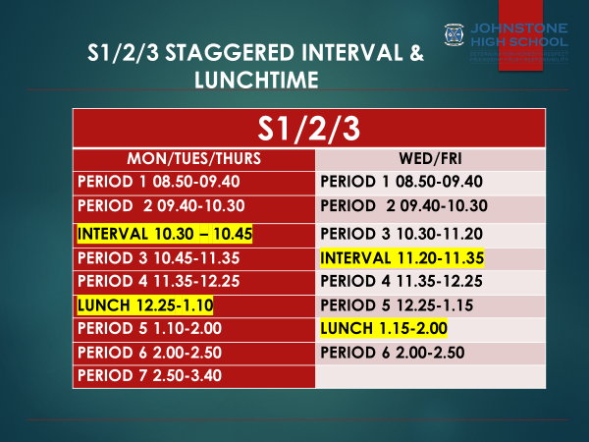

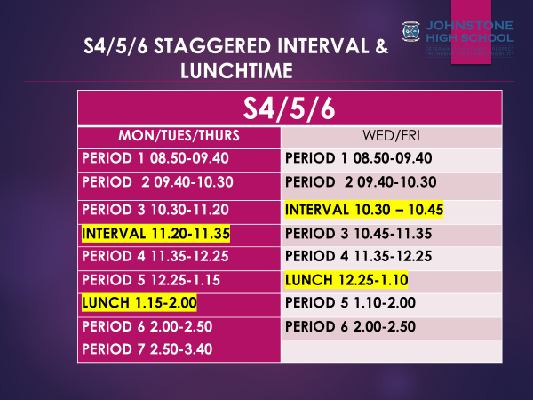

1. **Period changeovers**

In order to minimise congestion, we have a one-way system and there are plentiful signs and directional arrows to support pupils to navigate the building. We expect everyone in the building to comply with the one-way system even though we appreciate that it will mean that the ‘quickest route’ from A to B is often no longer accessible.

Pupils should not loiter in corridors at any time.

1. **Ventilation**

A key feature of Government guidance is the importance of ventilation to combat the spread of the virus. In schools, this means open windows and doors. Again, I encourage pupils to dress for the Scottish weather, and in the colder months we will allow pupils to keep jackets on in classrooms if this makes them more comfortable.

1. **Physical distancing**

As per government guidance, children and young people do not have to physically distance while in school or on school contract transport. However, in school we will continue to encourage physical distancing where possible to further minimise any risk. In addition, we will continue to avoid bringing pupils together in large groups e.g. assemblies. In classes, pupils will also be directed to sit side by side and facing forwards, rather than facing each other.

**Physical distancing will be in place between staff, and between staff and pupils. For the health and safety of our school community, pupils must stay 2m away from staff at all times. I am requesting parent/carer support on this and ask you to discuss this with your child to ensure full co-operation with this measure.**

1. **Face coverings**

All pupils are required to wear face coverings during lessons, in classrooms and corridors, unless they have a medical exemption.

1. **Absence and illness**

All schools have been advised to be vigilant for anyone in the school community (staff and pupils) displaying symptoms of the virus. If a Johnstone High School pupil displays symptoms, they will be isolated in our medical room and their parent/carer contacted to collect them.

For this reason, it is essential that we have up to date contact numbers for you and your child’s emergency contact e.g. grandparent / family friend. Please support us in this by completing your child’s data pack electronically on Parent Portal (S2-6 parents) or via the paper pack for S1 pupils, which will go home with them on the first week back.

If your child, or anyone in the household, is experiencing coronavirus symptoms, please follow the Scottish Government guidance around self-isolation and booking a test. **If your child tests positive, please contact us immediately.**

1. **Changes to contact tracing and self-isolation**

You will have read in the Director’s letter that there have been significant changes to contact tracing in schools. We will no longer be carrying out ‘contact tracing’ directly, as was the case throughout the previous session. Moreover, any child aged 5-18 will no longer have to self-isolate for 10 days if they are a contact of a positive case, so long as they remain asymptomatic and have a negative result from a PCR test.

1. **Hygiene and cleaning in the school**

Pupils should wash their hands before they leave home in the morning. During the school day they will be regularly reminded to sanitise. Pupils may also choose to bring their own hand sanitiser to school. Pupils should also sanitise their hands when they leave the building and before going on the contract buses.

Cleaning schedules have been increased throughout the school. During the school day, regular cleaning of hard surfaces and toilet areas will take place. Please note that in accordance with Renfrewshire Council guidance, **all pupils will be expected to wipe down their desk/chair each lesson** using reusable cloths and spray.

1. **Visitor/Parent access to the school**

For health and safety reasons, visitors coming into schools continue to be restricted. To keep everyone in our school community safe, **parents/carers should not come into the school building unless you have an appointment**, or there is an emergency. Instead, please phone or email the school to speak with us. Our contact details are at the top of this letter and the school number is 0300 300 1331. Pupils being collected for appointments during the school day should be met by parents/carers at main reception.

1. **School events**

Unfortunately, the current guidance advises that we cannot hold large gatherings; events such as information evenings, awards ceremonies, concerts and parents’ nights etc. These will be organised when we are advised it is safe for these to resume. As a result, we have not been able to finalise our school calendar for session 2021/22. When there is more clarity around these areas, we will get the calendar sent out to you.

1. **Curricular / extra-curricular provision**

We are now in a position to offer the full range of activity in Music and PE (delivery of these subjects had been limited last session due to covid restrictions on contact sports, indoor singing etc).

We have also been advised that there is no longer a need to keep S1 and S2 classes together in class bubbles. This will allow staff additional flexibility to bring together pupils from different classes, as and when appropriate.

We typically have a large and vibrant programme of extra-curricular activities that take place throughout the school year. Staff have been advised to consider alternative modes of delivery such as online clubs. Again, when it is safe to do so, I look forward to re-introducing our usual set of lunchtime and after school clubs.

I hope the above measures have provided you with the necessary reassurance that we have done all we can to ensure the safe return of your child to school. Hopefully these measures will reduce over the next few weeks and months, and we will continue to review our risk assessments in line with Scottish Government and Renfrewshire Council guidance.

Finally, I hope you enjoy the remaining days of the school holidays and I look forward to welcoming our pupils back to school next week.

Yours sincerely,



Lynne Hollywood

Head Teacher