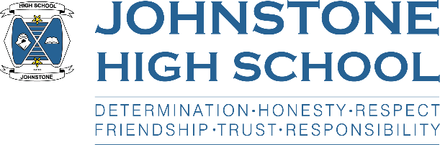**Head teacher weekly update**

**Friday 10th September 2021**

Dear Parent / Carer,

Here is the news for week 6 – 10th September:

1. **Covid Update**

This week we have seen more positive cases amongst pupils in school.

We are continuing with our health and safety measures, as per Renfrewshire and Scottish Government guidance and I ask for parental support in the following ways:

* **Please do not send your child to school with covid symptoms or if they are awaiting PCR test results**
* **Please ensure your child brings a mask to school and wears it**
* **I encourage you and your family to take part in the LFD home testing scheme – consent forms can be collected from Mr Munro DHT or parents can call the school office**
* **I encourage pupils over the age of 16 to be vaccinated.**

1. **MS Team Codes**

Since the start of term we have asked all teachers to set up a class MS Team code, S1-6. These have now been collated and will be going on the school website for parents/pupils to access.

Pupils who are self-isolating and are well enough to work from home can access class materials by going on to their class Team.

1. **2021-2022 Assessment Calendar**

The assessment calendar for S1-S6 has now been published on our website.

This spreadsheet shows an overview of all planned assessments for S1-S6 for the forthcoming academic year.

In order to view the most appropriate information use the filters at the top of the year group column to select the correct year group(s) you need to view.

Further information on each assessment will be posted on MS Teams/Satchel 1 in the lead up to the assessment and pupils will be prepared in lessons by their class teachers and will be notified of any changes to dates.

I hope you find this a useful tool to help your preparation for assessments.

1. **SQA Registrations**

We will shortly be starting to register S4-6 pupils for SQA Courses. Please can you make sure that the Address and Contact details the school holds for your child are correct and that you notify us of any changes asap. Thanks!

(You can access your child’s contact details via PARENT PORTAL on the Council website.)

1. **Parent calendar**

We are still waiting on final word from HQ on the Queen’s jubilee holiday – once that has been agreed we will get the calendar to you asap.

In the meantime, please note that school is closed for **September weekend** on:

**FRIDAY 24 SEPTEMBER**

**MONDAY 27 SEPTEMBER**

1. **Uniform and PE Kit**

Despite many gentle reminders from staff, there are a number of pupils coming into school in the morning wearing PE kit, and/or attempting to stay in PE kit for the rest of the day. Our changing room facilities are fully functional and there is no reason for pupils not to change into their school uniform.

Pupils are being challenged by staff whenever we see them inappropriately wearing joggies/ hoodies/ leggings and we will be calling parents for your support when young people fail to comply with the school rules around uniform and conduct.

1. **S6 News**

UCAS – we now have 60 pupils registered for UCAS this session and this is likely to rise.

Mr Munro would like to remind pupils that they should be having a first attempt at their personal statement and these drafts should be sent to him, in the first instance.

Captains – final 16 are being interviewed on Wednesday 15th September. Good luck to all!

1. **Vaccinations**

Please remember to return flu vaccination consent forms – these may be at the bottom of school bags! Vaccination day is 20th October.

Pupils will be receiving the nasal spray; staff are getting jags.

1. **Parent Council**

Thanks to all parents who attended the first face-to-face parent council meeting on Monday 6th September. When the minutes are finalised, they will be uploaded to the Parent Council page of the website where you can also access historic PC minutes/agendas, PC Chairperson reports and HT reports to the Parent Council.

With best wishes to you and your family,



Lynne Hollywood

Head Teacher