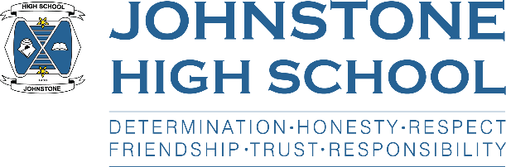**Head teacher weekly update**

**Thursday 23rd September 2021**

Dear Parent / Carer,

Here is the news for week 20-23rd September:

1. **Vaccination Update**

The flu vaccination (nasal spray) has been moved from Wednesday 20th October to Friday 22nd October. This opportunity is open to all pupils S1-6 and consent forms were sent home some weeks ago. These are filtering back into school, however if a family requires a fresh one please get in touch with the school office.

Covid vaccination for 12-15 year olds – you may have seen in the media that from Monday 20th September this age group can now have one dose of the covid vaccine.

During the first week, young people can attend drop-in vaccination hubs. From Monday 27th onward, young people will be receiving a blue envelope through the post with an invitation to a NHS vaccine centre. If this is during school time please get in touch with us, as you would with any other medical appointment.

Schools have also been informed that the NHS will embark on a programme of catch-up vaccination (as they do with, for example, HPV) in schools later in the year. We have no further information and when I hear more, I will inform parents/carers.

1. **Virtual senior awards ceremony for session 2020/2021**

Unfortunately, we are still unable to host a large gathering, therefore our senior awards have gone online.

Well done to the award winners from last session’s S4, S5 and S6.

Certificates and trophies will be issued next week, and we will post out certificates to pupils who have left school.

Here is the link for the 2020/21 Virtual Senior Awards<https://bit.ly/2XEpFG0>

1. **School transport update**

FAO parents of the pupils on Contract 5517J Brookfield/Kilbarchan: due to a road closure on Branscroft, Kilbarchan, the school bus with Marbill coaches will operate 10 mins early from Monday 27th September -  Sunday 10th October 2021.

1. **Open evening 4th October 2021**

Unfortunately, due to ongoing covid restrictions we are unable to go ahead with the planned ‘in person’ open evening for P7 pupils and parents on 4th October 2021. Instead we will put together an virtual tour of the school and will get this out to our cluster primary schools over the next few weeks.

1. **Update from Active Schools (Amy and Arron)**

Renfrewshire Active Schools have now launched our Pupil Activity Survey for 21/22. This short survey will allow your Active Schools Coordinators, Amy Couttie & Arron Dougan, to learn more about your child’s level of participation within sport and work to provide opportunities that are going to engage your child in sport and physical activity.  
  
We aim to receive back a survey from every student around Renfrewshire and we can only do this with parental support.  
  
If you have a spare minute, could we please ask you to fill out the survey below for your child/children.[*https://www.cognitoforms.com/RenfrewshireLeisure3/pupilsurveyphysicalactivityandschoolclubs*](https://www.cognitoforms.com/RenfrewshireLeisure3/pupilsurveyphysicalactivityandschoolclubs)

With very best wishes to you and your family,



Lynne Hollywood

Head Teacher