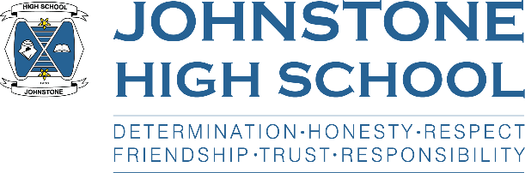**Head teacher weekly update**

**Friday 29th October 2021**

Dear Parent / Carer,

The school session is certainly in full swing as we complete another calendar month. October has gone in the blink of an eye. I hope that you and your families have a brilliant – and safe – Halloween this weekend and don’t forget that the clocks go back too.

Here is the news for week 25 – 29th October:

1. **Parent Council News**

The next meeting of the parent council is Monday 15th November, 7pm in the school staffroom (socially distanced). At this meeting we will be discussing the school’s ‘Insight’ performance – this is the national database that holds the attainment (SQA) information for all high schools in Scotland and allows us to compare our performance against others. There are many good news messages to share as our pupils performed well in session 2020/21.

1. **Assessment weeks**

Today marks the end of the first assessment period for the senior pupils. My congratulations to them all for working hard and getting through this first period of assessment. I know assessments and the ongoing uncertainty around exams are very frustrating and can cause our young people anxiety. Please get in touch with Pastoral Support if you feel your child is struggling or needs some extra support in school.

At the moment, the Scottish Government are saying that exams WILL go ahead in the ‘traditional’ fashion (i.e. rows in the assembly hall, exams throughout May etc). Therefore, it is vitally important that we get the young people into the swing of assessments under exam conditions, so they are well prepared. The only pupils in the entire senior school with experience of the traditional model of exams is S6, and the only exams they had were their prelims in S4. The October assessments took place in class however prelims are scheduled for December.

1. **Online parents’ evenings**

Information will be coming out next week for parents of pupils in S4 who are scheduled to have their online parents’ evening on 11th November.

S5/6 are scheduled for 23rd November, also online.

1. **Christmas Concert**

I am currently in discussion with the Music department about the Christmas Concert. It had been my hope this would be able to take place in December. However, there is still no sign of covid mitigations reducing, and as it stands schools cannot bring more than 50 people together out with lunchtime/breaks and specific educational activities. If there is movement from the Government, we may be able to put together a concert, but there will need to be a date when we draw a line under it. Our pupils need time to prepare and practice and we don’t want them to spend hours on something that doesn’t happen.

Therefore, we are exploring the possibility of an alternative to the concert – potentially an outdoor event – and will keep you posted when we have more information to share.

1. **Halloween Doors**

Well done to all the young people and staff who joined in with a little spooky fun by decorating their classroom door for Halloween.

Over £60 was raised for the foodbank and the winners were Learning Support, Miss Hamilton’s class, The Thrive Hive, Miss McLachlan’s class and Miss Semple’s class. Photos will be placed on our twitter page.

1. **Important reminders**

* Uniform checks start on Monday. Thanks for your support in this regard.
* Please sign up for parent pay (dinner money etc) and parent’s portal (report cards and the annual data check) if you haven’t done so already. If there are any issues, please contact our school office team who will do all they can to help.
* S4 parents’ evening is 11th November
* S5/6 parents’ evening is 23rd November
* Parent council is taking place on the evening of 15th November

1. **Forthcoming events**

* We will be collecting for Poppy Scotland from next week onwards.
* The autumn/winter newsletter is due out next Friday

With very best wishes to you and your family,



Lynne Hollywood

Head Teacher