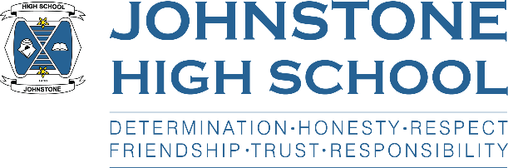**Head teacher weekly update**

**Friday 12th November 2021**

Dear Parent / Carer,

Here is the news for week 8-12th November 2021.

1. **Autumn Newsletter**

The Autumn newsletter is now on our website and twitter and will also be texted out to parents. We hope you enjoy reading our news from August and seeing some photos of life in school.

1. **School Holiday**

The school is CLOSED for the St Andrew’s Day holiday on Tuesday 30th November. Pupils should NOT attend that day 😊

1. **Parent Council News**

The next meeting of the parent council is Monday 15th November, 7pm in the school staffroom (socially distanced). Please check the school website for previous agenda and minutes of these meetings.

1. **Prelims**

Prelims are scheduled to take place 1st December – 20th December.

Mrs Cole has drawn up the timetable and it is currently with PTs for checking. It will be with pupils, parents and carers as soon as it is finalised.

1. **Online parents’ evenings**

We had our first online evening for parents of S4 on Thursday 11th November. A letter has been sent to S4 parents today (Friday 12th) along with an electronic survey to capture your feedback.

The next online parents evening is S5/6 on 23rd November.

1. **S6 Update**

As I mentioned in the update last week, Davy and Rebecca from the White Ribbon organisation led an awareness raising assembly with S6 boys on Monday 8th November. Many pupils signed the White Ribbon pledge – that they will not commit, condone or stay silent about violence against women – and 12 have volunteered to be part of a group working with younger students.

Each week we meet with S6 captains about their duties in school. This week we discussed Prom and hope to go to the year group very soon with a few venue options.

Myself and the two captains will be representing Johnstone High School at the Paisley Cenotaph for Remembrance Sunday this weekend.

The captaincy team are also supporting Children in Need, 15-19th November, and there are a lot of fun activities planned throughout the week.

The captains are also leading on a Christmas foodbank collection over the next few weeks, and information about this has already gone out to pupils and parents (next week we are looking for tins).

1. **BGE Homework club**

A reminder that homework club is on every Tuesday after school for S1-3 pupils in Miss Gribben’s English classroom.

1. **Senior School information Evening**

Our annual senior school information evening is on the calendar for the 17th of November. However, due to ongoing covid restrictions we are still unable to invite parents into the building for an in-person event. Therefore, we will send S4-6 parents a letter about this next week that will detail how you can access pre-recorded presentations on a variety of topics – all from the comfort of your own home!

With very best wishes to you and your family,



Lynne Hollywood

Head Teacher