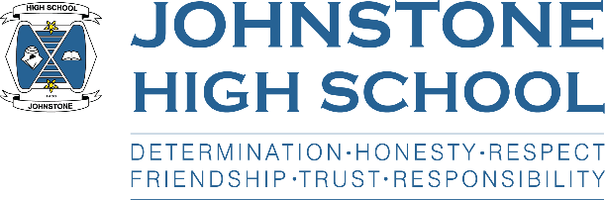**Head teacher weekly update**

**Friday 19th November 2021**

Dear Parent / Carer,

Here is the news for week 15-19th November 2021.

1. **School Holiday**

The school is CLOSED for the St Andrew’s Day holiday on Tuesday 30th November. Pupils should NOT attend that day 😊

1. **Parent Council News**

I met with the parent council on Monday 15th, 7-9pm on our school staffroom. We had a productive discussion on a range of key areas: staffing, school improvement, S6 matters, assessment and prelims, Christmas plans, Covid update and I also delivered a presentation on our school attainment from session 2020/21. The minutes of the meeting and HT report will be on our website in due course.

1. **Prelims**

Prelims are scheduled to take place 1st December – 20th December.

The timetable has been sent to parents and carers electronically and a paper copy has been issued to pupils.

The Support for Learning team will work with pupils who have alternative arrangements such as separate accommodation.

1. **Raising attainment booster classes**

This week we sent out the schedule of after school and online booster classes for S4-6 to give them additional support prior to prelims. Please encourage your child to sign up to as may sessions as possible. The link to this is also on the website.

1. **Online parents’ evenings**

The next online parents evening is S5/6 on 23rd November. A letter containing joining information has been sent to parents of S5/6 pupils, along with a ‘how to guide’.

PLEASE SIGN UP PRIOR TO 12PM ON TUESDAY 23RD NOVEMBER as this is when appointments close.

1. **Children in Need**

Our team of newly qualified teachers have led the school’s Children in Need activities throughout this week. We have had tuck shops every day, cake decoration, soak the teacher, staff vs pupils volleyball match, and the grand finale today was ‘The Chase’ – pupils against Mr Munro!

Over the week we managed to raise £416.50 which is a tremendous effort from all concerned. Well done everyone.

1. **BGE Homework club**

A reminder that homework club is on every Tuesday after school for S1-3 pupils in Miss Gribben’s English classroom.

1. **Senior School information Evening**

This week we sent all S4-6 parents a letter about how you can access pre-recorded presentations on a variety of senior school topics. If there are any questions or issues, please contact Mr Munro.

1. **S1 Panto trip**

We are hoping to take all of S1 to the Kings Theatre on Wednesday 15th December for panto.

Pupils in receipt of free school meals/footwear and clothing grant **do not have to pay** for this trip.

If there are any other families who need support to meet the cost of this trip, please contact either your child’s pastoral teacher or Principal Teacher of English, Mrs MacLeod, for a confidential and discreet conversation. We are keen to help as we would like as many of S1 to take part as possible.

1. **Christmas Jumpers**

Friday 10th December is Christmas jumper day. This year we are asking for donations of old jumpers that we will launder and then recycle so someone else gets the use of them. We realise these jumpers are expensive but are hardly worn before our children grow out of them. If you have any old jumpers, please send them into school. Thanks.

1. **Foodbank**

We received a letter form the Renfrewshire Foodbank this week to tell us that our collection in October raised 623.8kg of items which equates to 1485 meals.

We are currently in the process of weekly collections for the Foodbank, and these will finish just before Christmas. This week was tins, next week is selection boxes.

As ever, we are truly grateful for the generosity of our pupils and parents.

With very best wishes to you and your family,



Lynne Hollywood

Head Teacher