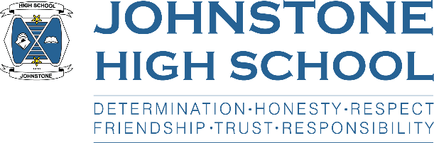**Head teacher weekly update**

**Friday 5th November 2021**

Dear Parent / Carer,

Here is the news for week 1 – 5th November 2021.

1. **Uniform Checks**

This week senior staff have been visiting classes each morning to check uniform. This has already had a positive impact in reducing the numbers of young people now appropriately dressed for school.

My thanks to parents and carers for your support with this.

1. **Parent Council News**

A little reminder that the next meeting of the parent council is Monday 15th November, 7pm in the school staffroom (socially distanced). Please check the school website for previous agenda and minutes of these meetings.

1. **Prelims**

Prelims are scheduled to take place 1st December – 20th December.

Mrs Cole will issue more information to pupils and parents soon.

1. **Online parents’ evenings**

S4 parents should have received a text and also a letter posted home. These detail everything you need to know about logins and joining instructions. We are looking forward to meeting you, virtually, on Thursday 4.30 – 7pm.

1. **Christmas Plans**

Covid continues to impact what we are safely able to provide in terms of events in school, however we are doing our best to work around these and provide the pupils with a memorable Christmas experience. Our parent council Christmas Fayre had to be cancelled due to maximum gathering sizes, similarly the Christmas Concert. However, the Music department are working on a plan B, so fingers crossed.

The English department are hoping to take ALL S1 to the Kings Theatre for panto on Wednesday 15th December. Letters are being issued to S1 with all the details. Please note that we have contacted parents in receipt of free school meals / clothing and footwear grants to let them know that there will be **no charge** for their child to go to panto.

If any other families (not in receipt of these benefits) need support with the panto cost, please get in touch with your child’s pastoral teacher, or Mrs Macleod the PT of English, for a confidential conversation about how we can help.

Christmas jumper day is 10th December.

Christmas lunch in school is penciled on for 16th December.

And we hope to have some fun activities on the last day of term (we close for Christmas holidays on 22nd December at 2.30pm).

1. **S6 Update**

Each week we meet with S6 captains about their duties in school.

This week we discussed Prom, and the 12 captains have set up a group to get this organised – visits to venues is the first big job, then a final decision on a date and location.

The captains are also supporting Children in Need, 15-19th November.

On Monday 8th November all S6 boys will be taking part in an assembly delivered by White Ribbon. This is a government backed charitable organisation that seeks to raise awareness about male violence towards women and girls. This sits with our ‘mentors in violence prevention’ programme – we have a number of senior pupils trained to support other pupils not to be ‘bystanders’ and instead challenge unacceptable language and behaviour. This is very powerful, especially when it is young people challenging other young people on what is ‘ok’ and ‘not ok’ in our modern Scottish society.

Having met with a representative from White Ribbon, I expect this to be a very interesting and thought-provoking insert for our senior male pupils.

1. **Important reminders**

* ONLINE S4 parents’ evening is 11th November
* ONLINE Senior school information evening is 17th November
* ONLINE S5/6 parents’ evening is 23rd November
* Parent council is taking place on the evening of 15th November
* SCHOOL CLOSED Tuesday 30th November (St Andrew’s holiday)

1. **Forthcoming events**

* We will be collecting for Poppy Scotland from next week onwards.
* We will be delivering an online Remembrance service on 11th November.
* The autumn/winter newsletter will be with families, electronically, next week (thanks for your patience)

With very best wishes to you and your family,



Lynne Hollywood

Head Teacher