PUPIL BULLETIN 25 November 2019

- Note from Mrs Hollywood

Good luck to everyone starting their prelims this week. Remember to read the questions, keep calm and do your best.

On Wednesday we are hosting the Parent Council Christmas Fayre. I hope to see you all there – please support your school.

- Prelim Exams

- Prelim exams start on Friday the 29th November all the way through to the 18th December.
- During this time pupils will not be allowed to walk through to the dining hall/café from reception. ALL pupils must enter by the door at the back of the canteen (next to technical).
- Pupils will not be allowed in the area outside the assembly hall AT ANY TIME- this includes changeover of lessons.
- Prelim exams will be on over break and lunchtimes as well so please walk very quietly around the assembly hall, particularly on the stairs leading up to languages.

S4/5/6

Please remember that Prelim exams provide importance evidence of your progress in each subject area. Therefore they should be approached in the same way as the final exams.
- Use the topic lists, revision activities and techniques provided by your teachers to fully prepare for your Prelims.
- Make sure you know the date and time of your exams – order/bring lunch if you need it, especially if your exam runs into lunchtime.
- NO MOBILE PHONES/APPLE WATCHES/OTHER ELECTRONIC DEVICES to be brought into the exam hall/exam room.
- Only clear plastic water bottles allowed in the exam hall- no labels.
- Bags/Jackets to be left in the S6 study room ( when not in use) or the back of the hall (phones MUST be switched off)
- Check your seat number/exam location on the exam board outside the assembly hall
- Arrive for your exams 10 minutes before the start time.
- Bring the card with your candidate number to each exam.
- If you do not have an exam you should be IN LESSONS.

Good Luck!!

- London Trip

London Trip
Unfortunately the London Trip has to be cancelled this year. However in April forms will be issued for next year.
Mrs. Irving

- Badminton
4 pupils attend a badminton tournament at the ON-X Linwood on Tuesday 19th November:

James Tennant
Angus Poole
Mathew McIvor
Cheyanne Kelly
They were all successful in representing the school

- Supported Study Dates

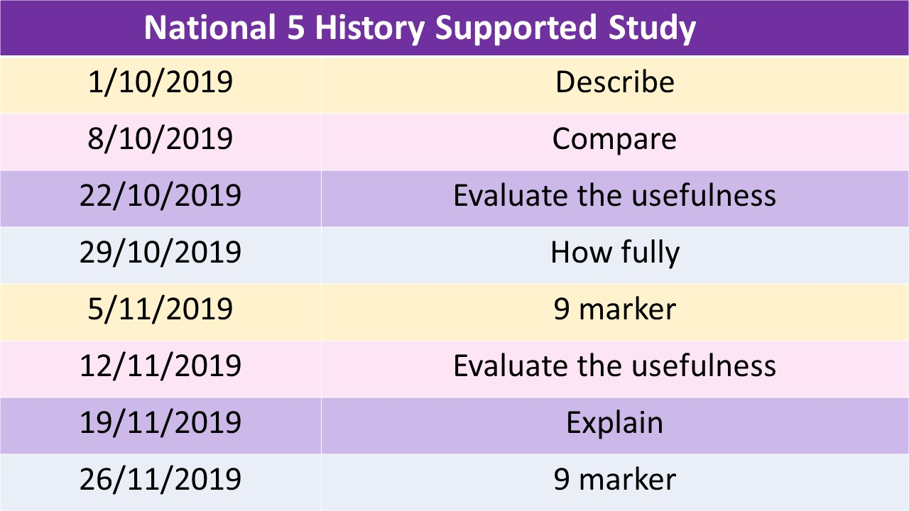

- LANGUAGES CLUBS!

SPANISH - ML4 - MONDAY LUNCHTIMES FOR S1
GERMAN - ML3 - WEDNESDAY LUNCHTIME - ALL YEAR GROUPS WELCOME
BSL - ML4 - THURSDAY LUNCHTIME - ALL YEAR GROUPS WELCOME
FRENCH - ML4 - FRIDAY LUNCHTIME - ALL YEAR GROUPS WELCOME
SUPPORTED STUDY
SPANISH - ML4 - TUESDAYS
GERMAN - ML4 - WEDNESDAYS
FRENCH - ML4 - THURSDAYS
S6 BSL
WORK TOWARDS A QUALIFICATION IN BRITISH SIGN LANGUAGE!
Classes Wed lunchtimes and Friday after school (3-4pm) in ML4
See Mrs Kilgour to get added to TEAMS.

- Maths Supported Study
There will be supported study classes for S5/6 National 5 every Wednesday after school.

6. Music

Monday Lunchtime - Percussion Group - S1-S6 - Mrs Davidson’s Room
Tuesday Lunchtime - Junior Choir - S1-S3 - Miss McPherson’s Room
Tuesday Lunchtime - Senior Choir - S4-S6 - Mrs Davidson’s Room
Tuesday Lunchtime - String Group - Practice Room - Miss Rush
Thursday Lunchtime - S1/2 Instrumental Group - Miss McPherson’s Room
Friday After School - Pipe Band - Mr Bowes

7. Barcelona Music Trip

Spaces Remaining - See Mrs Davidson or Miss McPherson for details

- Hockey Club

The hockey club will be running on Thursday 4pm – 5pm on the astro turf or indoor hall. This is open to all year groups.
The school will be looking at entering two teams into the Renfrewshire School Leagues this year. A great opportunity to have fun and play a new sport. Come along and give it a try.

Contact Mr Scholefield for more details

- Social Subjects

Social Subjects twitter page @JSubjects. Pupils in all year groups should follow and check this for news and info about Social Subjects & RE.

- English Dept Clubs
Monday Lunchtime - Umbrella Club - Miss McFadden's Room (E1)
Tuesday Lunchtime - Public Speaking and Debate Club - Miss Hamilton's Room (E4)
Sci-Fi and Fantasy Club - Miss Gribben's Room (E3)
Friday Lunchtime - Creative Writing Club - Miss Gribben's Room (E3)

- Lunchtime Fitness
Fancy getting fit in time for Christmas? Come along to the Dance Studio at 12.35 every Wednesday for a 20 minute Metafit style workout. Hope to see you there.

- Pupil Council News
The Junior Pupil Council met for the first time and have decided that their priorities for this session:
Window Blinds
Water in PE
Toilets
If you have any comments that you would like to make about these, or any other subjects, please put a note in the Suggestion Box at the reception desk.

- PE Extra-Curricular Timetable
Day | Time | Activity | Year Group | Teacher
Monday | After school | Girls Football | All | John Martin (Active Schools)
 | After school | Dance (Dance Studio) | S1-3 | Miss Ashmole
Tuesday | After school | Netball | All | Miss Ashmole/Miss McIntosh
Wednesday | After school | Trampolining | All | Miss Ashmole
 | Lunchtime | Dodgeball | S1-3 | Mr Murray
 | Lunchtime | Fitness (Dance Studio) | All | Mrs Smith
Thursday | After school | Dance | All | Miss Ashmole
 | After school | Hockey | All | Mr Scholefield
 | Lunchtime | Volleyball | S1-3 | Mr Merriman
Friday | Lunchtime | Futsal | S1-2 | Mr Stevenson
 | Lunchtime | Badminton | All | Mrs Wightman
 | After school | Running | All – pupils and staff | Mr Murray

- Guitar Club

Mr McKenzie is running a Guitar Club in Science Lab 1 on Friday at lunch time. This is open to all pupils.

