Johnstone High School 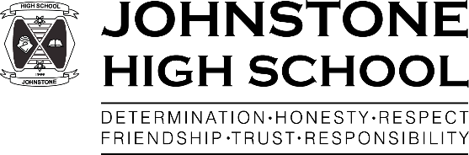

Beith Road

Johnstone

PA5 0JN

Tel: 0300 300 1331

[www.johnstonehigh@renfrewshire.gov.uk](http://www.johnstonehigh@renfrewshire.gov.uk)

johnstonehighenquiries@renfrewshire.gov.uk

20 March 2020

Dear Parent/Carer,

**FURTHER INFORMATION ON DIGITAL LEARNING FROM RENFREWSHIRE COUNCIL**

You will be aware of the announcement to close schools this Friday. We understand that this will cause a disruption to the normal pattern of learning for your child or young person and want to do all we can to support them in making use of digital tools and online learning resources such as Glow.

Glow is free to all children and young people can be accessed by them using their Glow login and password; it can be accessed anytime, anywhere and on any device. Once on, they will be able to work on their own or link and work with their classmates.

Some of the Glow tools which they may use are:

* Microsoft Teams
* Google Classroom
* Glow blogs

These tools will allow them to view suggested homework tasks, follow a set of instructions and complete work assigned by their teacher(s).

You can find out a little more about how each of these tools work using the links overleaf:

**Microsoft**

<https://support.office.com/en-us/article/remote-learning-with-office-365-guidance-for-parents-and-guardians-89d514f9-bf5e-4374-a731-a75d38ddd588>

**Google Classroom**

[https://edu.google.com/products/classroom/](https://edu.google.com/products/classroom/?modal_active=none)

**Glow Blogs**

<https://glowconnect.org.uk/about-glow/glow-for-parents/>

In Renfrewshire, as is all other local authorities, we have an Acceptable Usage Policy that is shared with all children and young people at the start of the school session. The key points from it are listed below for you and it might be an idea to remind your child or young person of the need to stick to the policy when using digital platforms like Glow for learning and schoolwork. This will ensure they stay safe and keep others safe while online.

* *I will always be polite and will not use bad language.*
* *I will remember that anything I do can usually be traced back to me.*
* *I will not access, create, store or distribute files that could be thought of as offensive or indecent, or that harasses or insults others.*
* *I will not share my personal details or any personal information about other people (home address, phone number etc) in emails, on the internet or with other people.*
* *I will only send emails to people I know, or my teacher knows.*
* *I will not arrange to meet people I talk to online.*

We understand how anxious a time this is for you. This information relates to an unprecedented way of working, but we want to continue to support all children in their learning throughout this period in whatever way we can and hope that you find this helpful.

Please note that you can also email the school via:

johnstonehighenquiries@renfrewshire.gov.uk

Yours sincerely,

Lynne Hollywood