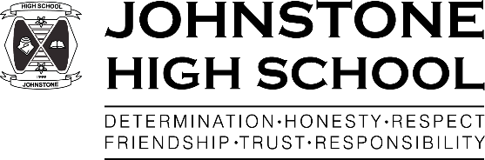Johnstone High School

Beith Road

Johnstone

PA5 0JN

Tel: 0300 300 1331

[www.johnstonehigh@renfrewshire.gov.uk](http://www.johnstonehigh@renfrewshire.gov.uk)

[johnstonehighenquiries@renfrewshire.gov.uk](mailto:johnstonehighenquiries@renfrewshire.gov.uk)

12th November 2021  
  
Dear Parent/carer,   
  
Children in Need 2021 is on track to be a week of fun and enjoyment for all pupils and staff members across Johnstone High School. We have many fabulous events planned for the week of 15th-19th November.

Pupils should expect to see tuck shops of sweet treats and healthy alternatives available throughout the week during break times, as well as a range of exciting activities during lunchtimes including ‘Soak the teacher’, The Great Johnstone High Cake-Decorate-Off and we will be putting our pupils’ knowledge to the test with a Chase-Style show down on Friday 19th.

To sign up for each event throughout the week, we ask that pupils donate £1 per activity to raise as much money as we can for such a worthwhile cause. We are also suggesting pupils might want to add a little something fun to their uniform on the Friday to match the Children in Need theme. Take some inspiration from Pudsey and maybe wear a spotted tie or even some Pudsey ears?   
  
Children in Need is a time for us all as a school community to come together and have fun. It is also a time to think of others and do all we can do to support them as a school.   
  
Best wishes,  
Johnstone High School Newly Qualified Teacher’s team.