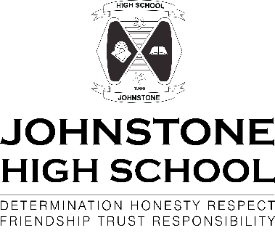

Dear Parent/ Carer

Senior Information Evening 2021

As you will be aware the school holds an annual Senior Information Evening with topics that will be of interest to pupils in S4, S5 and S6 and their parents. This is the second year this evening has been delivered virtually.
This year there will be online presentations available on
- SQA and plagiarism
- UCAs and university applications
- Employability
- SQA qualifications procedure 2022
- Study skills
- Mental Health
There will also be study packs that the pupils can collect from their Depute Head Teacher from Wednesday 26 Nov.
Listed below are the web links to each of the presentations.
Study Skills For Parents: https://vimeo.com/645116207

Plagiarism and SQA Advise: https://vimeo.com/645115949

DYW Presentation: https://vimeo.com/645116061

SQA Update: https://vimeo.com/645116129

Due to the size of the UCAS presentation this will be held as a live MS Teams event.
If you are keen to have this information, then can you send an email to myself. My email address is
Graham.munro@renfrewshire.school. I will then schedule a meeting and send you a code to allow you to join. This meeting will be held in the next 2 weeks.

To allow easy navigation we recommend, depending on the pupil’s stage and desired career path to watch the following
S4 pupils all videos (the UCAS presentation is aimed mainly at pupils applying for university in 2022 for entry in 2023 and beyond)
S5 and S6 pupils and not considering university SQA plagiarism Employability SQA arrangements 2022
S5 and S6 pupils and considering university SQA plagiarism UCAS SQA arrangements 2022
We recommend that all pupils and their parents watch the study skills and mental health presentations.

We hope that you find the information useful and supportive to you and your child(ren). If you have any further questions, please contact your child’s pastoral support teacher on 0300 300 1331

Yours sincerely

Graham Munro
Depute Head Teacher

