**Head teacher weekly update**

**Friday 3rd December**

Dear Parent / Carer,

Here is our news for this week:

1. **S5/6 Parents’ Evening (23rd November)**

The survey for S5/6 parents went out on Wednesday this week. Thanks to those who have already responded.

The feedback so far is that the majority of parents are enjoying the online set up, but many feel the 5 minute appointment slot is too rushed. However, 5 mins is the time we allocate during ‘traditional’ evenings, as this is really the only way staff can get through classes of 30 in the time available. In traditional evenings, staff sometimes over-run, however the online version has no scope for this.

1. **S2 reports and S1 tracking**

S2 reports went home to parents and carers this week.

S1 tracking reports should be with parents by Christmas.

Please remember that if there are any issues or concerns, please contact us at the school on 0300 300 1331.

1. **Vapes**

We have noticed a number of young people bringing vapes into school. This is NOT ALLOWED, and each time we see these, they are confiscated, we phone home and an appropriate sanction is put in place.

I am very concerned by the growing popularity of these vapes amongst young people. Parents should be aware that these can look like highlighter pens, therefore I have attached a photo of the ones we have confiscated in the past few weeks.

Of particular concern is information we have been given information by Trading Standards about illegal, counterfeit vapes and the health issues these are causing (adverse reactions).

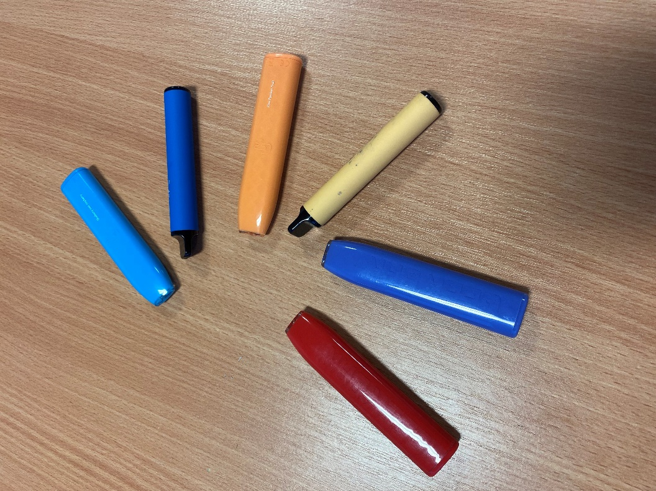

1. **Options process for August 2022**

Next week Mr Menzies will send out information about our options information evening, which was scheduled to take place on 14th December, and is now going online due to ongoing covid restrictions around parents coming into school.

This will not be a ‘live’ event – on the 14th we will send a link to a presentation that you can view at a time that suits you.

1. **Young Enterprise**

Congratulations to the Young Enterprise group who came second at the Renfrewshire Trade Fayre on Thursday 2nd December at Braehead. Well done to all staff and pupils involved! Below is some information about the group:



*“Our Mission is to take a CAN do attitude to the reincarnation of common household rubbish. We aspire to provide a new lease of life to an item previously unloved.*

*We are selling grow your own herb kits (Rosemary/Basil/Coriander). The pots are made from recycled tin cans that have been hand painted with natural colours. All of the packaging is also recycled or recyclable.*

*The customer gets a gift bag with the Tin (pot), Soil and Seed packet. Along with growing instructions and a recipe card. (At the moment these are Christmas themed). They are £3.50 each or 3 for £9.*

*Here is a picture of the products on display at the Trade Fayre:*

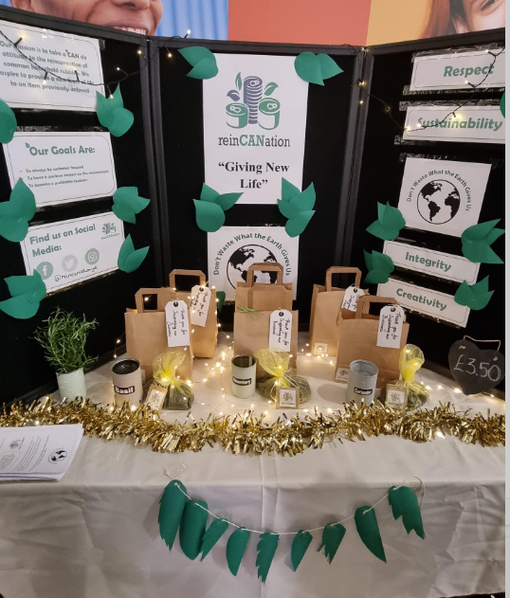

*It was our stall display and interaction with the judges about our brand and decision-making processes that won us an award.”*

1. **Prelims**

Prelims are going well so far, and this is a plea for parents to remind their young people to bring the appropriate equipment, arrive on time, and take up the offer of supported study whenever it is available. Thank you.

1. **Christmas in school**

Here are some important dates for your diary:

Friday 10th December Christmas Jumper Day

Tuesday 14th December S1 Panto trip

Thursday 16th December Christmas lunch

Wednesday 22nd December Non uniform day and we close for Christmas hols

We had plans for fun events, such as a Concert, Christmas Fayre, interhouse games etc – however ongoing covid restrictions has meant these are not possible. However, we will try our best to being the Christmas spirit into school in other ways!

With very best wishes to you and your family,



Lynne Hollywood

Head Teacher