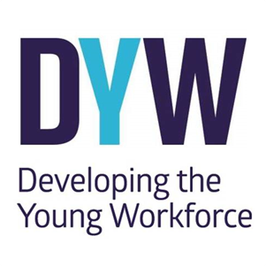
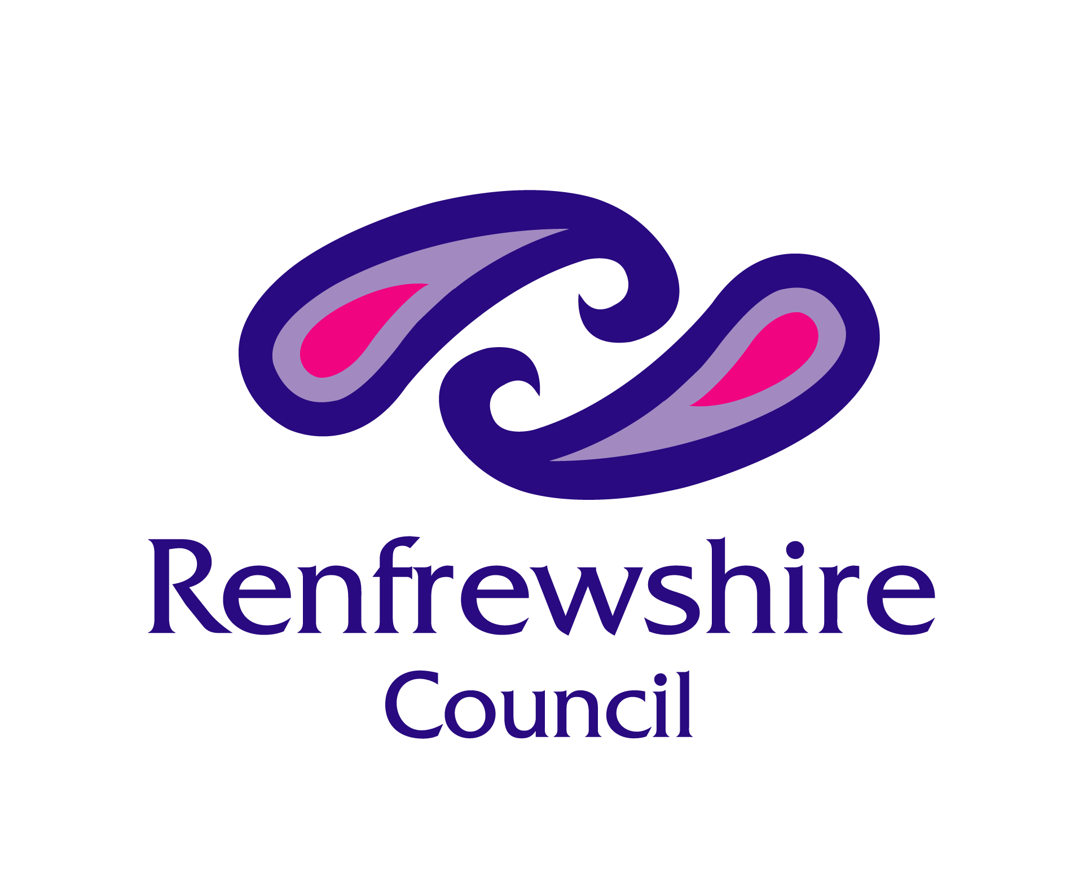

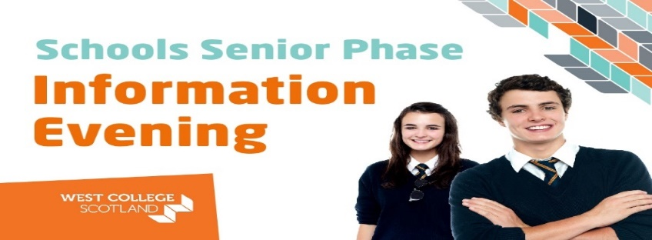

Thursday 20th January 2022
18:00pm – 19:00pm

- Calling all Renfrewshire pupils, parents & guardians!

- Come along to our Virtual event to hear about our Senior Phase options at West College Scotland

- You will receive a short presentation given by WCS who will give an overview of courses available – both within our Foundation Apprenticeship and School Vocational Programme

- After the presentation is finished, there will be a chance to ask questions

- If you are interested in attending this Virtual event please register now and the website to register for the event is called: Schools Senior Phase Information Evening - West College Scotland

