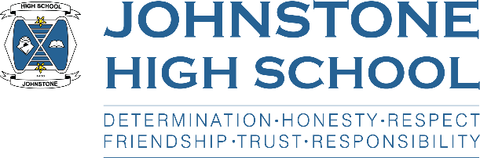

Parental consultation on
School Improvement Planning (session 2022/23)

Each year Johnstone High School produces a school improvement plan.

By speaking with parents / pupils / staff and by analysing our data (e.g., pupil attainment data) we identify our strength and development areas, and plan accordingly for the next school session.

- We will be getting the views of parents at the Parent Council AGM on 23rd May.
- We will also be sending out an electronic survey to all parents to capture your views.
- Finally, we are also offering an in-person drop in for parents on:

Tuesday 31st May, 5pm – 6pm, in the school assembly hall

We are keen to hear your views on school improvement priorities, post-covid, and how we spend our ‘pupil equity funding’, which each school receives directly from the Scottish Government.

Warm regards,
Mrs Hollywood

