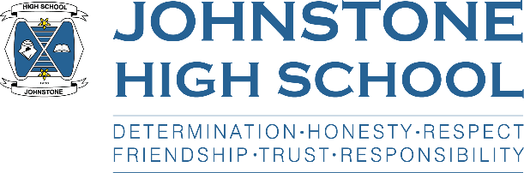**Head teacher weekly update**

**Friday 10th June 2022**

Dear Parent / Carer,

Here is the news for the week ended 10th June 2022:

1. **Reminders about expectations**

In my previous HT update, I mentioned we have been prioritising behaviour, uniform and punctuality with the pupils. This week we had fire alarm activations, one from a boys’ toilet and one from a girls’ toilet. One was a vape, and one was activated by aerosol deodorant. We have also experienced vandalism in the boys, and flooding in the girls. Therefore, sadly I have made the decision to close all toilets with the exception of the communal milling area toilets, and the single cubicle toilets dotted about the building. We will be enhancing staff supervision in the milling area and any pupils who are found to be vandalising our building or vaping on school premises will have the appropriate sanctions put in place. Parental support in this area is very much appreciated. Similarly, please make sure your child does not bring spray deodorant / body spray to school.

1. **Work experience**

S3 (new S4) work experience went ahead for many pupils last week. This was put together by Miss Docherty and the Pastoral team at fairly short notice (because of the lifting of the restrictions at Easter) and we are really pleased that a good number of our pupils managed to secure a placement. We will endeavour to make sure all pupils in S4-6 experience a work placement at some point in their senior school time.

1. **S6 Prom**

On Tuesday 7th we had a very successful S6 Prom at the Glynhill Hotel. The young people were a credit to their families and the school, and the night was a great success. Many thanks to Miss Vernal who organised the event, along with several staff and S6 helpers.

1. **Authority Visit**

On Thursday 9th we had a visit from our link Head of Service, Julie Calder, and Education Manager, Maureen Sneddon. They met with myself and the depute head teachers for a couple of hours to discuss attainment, positive destinations, our pupil equity fund spending and improvement planning. The meeting went well, and we received positive feedback about the work we are doing, particularly around the new courses we have put into the curriculum offer in the senior phase.

1. **S1-3 awards ceremony**

On Thursday 9th June we had our first in-person award ceremony since 2019. We had a lovely evening celebrating some brilliant young people alongside their parents and carers. Many thanks to all the staff who helped organise this event.

1. **Timetable update**

The new timetable has now gone through a complete cycle, and almost all young people with an issue have managed to meet with Ms Price and get their timetable sorted for 2022/23. We know that this is subject to change once exam results are in; we will communicate with parents and carers our arrangements for ‘renegotiations’ after results day at the end of the summer holidays.

1. **Improvement planning**

Many thanks to the 200+ parents who took the time to respond to the survey we sent out last week about our improvement priorities for next session. It also asked parents about your views for in-person vs online parents’ evenings for session 2022/23. We will be in touch soon to let you know the results.

1. **Next session**

At the start of each session, I write to parents with arrangements for the year ahead, and in the pack there usually contains:

* Welcome letter from Head Teacher
* Calendar
* Religious observance opt-out
* Photo/video permission
* Data check (your contact details)
* Parent council info and application etc

The pack will be coming out to you over the summer holiday period. We will have paper packs for any families who prefer this, but the main communication method is now online, via ‘parent portal’. You can access this via the council website. If you have any issues with parent portal, please call the office on 0300 300 1331.

1. **Dates for your diary**

Wider achievement awards (afternoon, in school, invited pupils only) – Tue 14th 2pm

P7 three-day visit – 15-17th June

Music Concert – Tuesday 21st June, 7-8pm (tickets available from the Music Dept)

Activities day – Mon 27th June

School closes 1pm – Tuesday 28th June and it’s also a non-uniform day

With best wishes to you and your family,

**Yours sincerely,**



Lynne Hollywood

Head Teacher