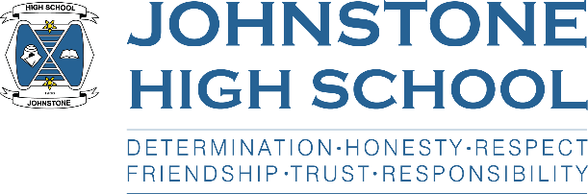**Weekly Head Teacher Update**

**29th August 2022**

Dear Parent / Carer,

We have enjoyed a very busy first two weeks of term and everyone is now starting to settle back into school life.

Firstly, thank you all for your support over summer in terms of school uniform – our young people are looking very smart. If any family needs a helping hand around any aspect of school uniform / kit / resources please get in touch for a discreet and confidential chat. We are here to help.

Secondly, I am very grateful to all the parents and carers who have taken the time to complete our start of session paperwork. For S1, we sent a paper pack home in the school bag, and for S2-6 we sent the relevant documents via email. Parents were then sent an online survey to capture your views and permissions in a ‘one-stop shop’. If you haven’t completed this yet, we would really appreciate you filling it out soon, thank you.

Here are some of the activities that have been going on in school over the past two weeks:

* S1 have settled in well and had S6 befrienders looking after them for the first week. We have plans for befriender breakfasts this week to keep the link going.
* Some S5s and nearly all S6 have completed first aid training.
* We have appointed 50 S5/6 prefects and they started their duties (i.e. supporting supervision) last week. After competitive interviews we also appointed 10 S6 vice captains, and congratulations to S6 pupils Daisy and Grace who have been appointed as our school captains.
* On Thursday we welcomed parents and carers into school for our senior awards ceremony – our assembly hall was jam-packed and it was wonderful to see our community come together to celebrate brilliant young people. Over 100 pupils received 200+ awards such as subject prizes, Duke of Edinburgh, Saltire (volunteering), and our ‘special’ prizes. I would like to mention both Chantelle who received the Head Teacher award, and Ada, who received the Hinshelwood award as the highest performing senior school (S5) pupil.
* We had house assemblies on Friday last week on the topic of ‘what it means to be a proud member of the Johnstone High School community’. Uniform, timekeeping, appropriate behaviour and manners in school and in the local community were all discussed.
* Ms Price, acting DHT, has been supporting the remaining senior pupils who have had timetable issues. All pupils should now have finalised timetables.
* Mrs Davidson, acting DHT, has been overseeing the SQA appeals process. At this stage, any pupil considering an appeal (if their SQA grade was lower than their estimate) should have spoken to the department PT. If there are any questions or concerns about the appeal process, Mrs Davidson is the point of contact.
* S6 have been supported to sign up for UCAS at lunchtime sessions this week. It’s very important for pupils wanting to apply for medicine or the conservatoire that they are well organised, as their closing date is October, not January.

Finally, we are looking forward to a pupil organised ‘freshers’ fayre’ in the next few weeks. This will be the opportunity to sign-up for clubs and activities. I am also delighted to let you know that staff have approached me about running residential trips this session! When details are finalised, we will be in touch with details.

With best wishes to you and your family,



Lynne Hollywood

Head Teacher

---------------------------------------------------------------------------------------------------------------

If you need to contact us, please call 0300 300 1331 and ask to speak to your child’s pastoral teacher:

**PASTORAL PT DEPUTE HEAD TEACHER**

ARRAN Mr Rainey Mrs O’Malley

IONA Miss Docherty Ms Cole

MULL Miss McFadden (acting) Mrs Davidson (acting)

SKYE Mr Kennedy Ms Price (acting)